LOYOLA MEN’S HOSTEL MANAGEMENT SYSTEM
Project Report Submitted to Loyola College, Vettavalam for the Partial Fulfilment for the Award of the Degree of
BACHELOR OF COMPUTER APPLICATIONS

By

VIGNESH.V [23021U09049]

UNDER THE GUIDANCE OF

Prof. J. KALAIYARASI., MCA.,
Asst Professor, Department of Computer Applications
Loyola College, Vettavalam.



DEPARTMENT OF COMPUTER APPLICATIONS
LOYOLA COLLEGE
(Accredited with B+ by NAAC,
Affiliated to the Thiruvalluvar University)
Vettavalam-606 754, Tiruvannamalai.

MARCH/APRIL - 2024



BONAFIDE CERTIFICATE

Certified that this project report titled “LOYOLA MEN’S HOSTEL MANAGEMENT SYSTEM” is the bonafide work of VIGNESH V, who carried out under my supervision and guidance. Certified further, that to the best of my knowledge, the work reposted herein does not form part of any other project report or dissertation on the basic of which a degree or award was conferred on an earlier occasion on this or any other candidate.

Internal Guide  Prof. J.KALAYARASI., MCA.,  Asst. Professor Department of Computer Applications | Head of the Department  Prof. S. DHARMARAJ, MCA, MBA,  M. Phil., Asst. Professor & HOD, Department  of Computer Applications

Submitted to the Viva Voice Examination held on …………………………

INTERNAL EXAMINER EXTERNALEXAMINER

DECLARATION

I hereby declare that this project work titled “LOYOLA MEN’S HOSTEL MANAGEMENT SYSTEM” Submitted to Loyola College, Vettavalam (Affiliated to Thiruvalluvar University), In partial fulfilment of the requirements for the award of the degree of Bachelor of Computer Applications is a record of original work done by me under the guidance of Prof J.KALAYARASI., MCA., Department of Computer Applications, Loyola College Vettavalam, and this project work has not formed the basic for the award of any Degree/Diploma-/associate ship/fellowship or similar title to any candidate of any other university

VIGNESH V

Place:
Date:

ACKNOWLEDGEMENT

I thank the almighty God for giving me physical mental strength and the ability to effectively complete this project.

I take this opportunity to express my deep sense of gratitude and respectful regards to out honourable secretary& correspondent Rev. Fr. Dr. A. Ignacy Arockiasamy, S.J., for various facilities provide to me. I dedicated my sincere thanks on this occasion to our respected Principal Rev. Fr. Dr. S. Basil Xavier, S.J.

I thankful to our respected HOD Prof. S. Dharmaraj, MCA, MBA, M.Phil., [Ph.D.] Department of Computer Applications, LOYOLA COLLEGE, VETTAVALAM, Tiruvannamalai for his consistent encouragement during the project work. His motivation helped me to achieve great things, during the course of study.
I thankful to our respected Internal Guide Prof J.KALAYARASI, MCA., Assistant Professor, of Computer Applications, LOYOLA COLLEGE, VETTAVALAM, Tiruvannamalai for his consistent guidance during the project work.

Finally with great enthusiasm I express my thanks to all my department lectures for providing necessary information and their sustained interest in my part of truthful completion.

VIGNESH V
23021U09049

LOYOLA MEN’S HOSTEL MANAGEMENT SYSTEM

TABLE OF CONTENTS

CHAPTER NO | CONTENT | PAGE.NO
Chapter 1 | 1. Introduction  1.1 ...…... Abstract  1.2 ...….... Overview  1.3 ……... Problem Statement  1.4 ……... Existing System  1.5 ……... Proposed System  1.6 ……... Feasibility Study  1.7 ……... Conclusion | 1  2  2  2  3  4  4
Chapter 2 | 2. System Requirement & Specification  2.1 ……... Hardware Requirement  2.2 ……... Software Requirement  2.3 ……... Module Description  2.3.1 …… List of Modules  2.3.2 …... Description of Modules | 5  5  5  5  6
Chapter 3 | 3. System Analysis & Design  3.1 ……... Use Case Diagram  3.2 ……... Data Flow Diagram Level - 0  3.2.1 ……. Data Flow Diagram Level - 1  3.3 …….... Class Diagram  3.4 …….... Sequence Diagram  3.5 …….... E-R Diagram  3.6 Database Table Design | 10  11  12  13  14  15  16
Chapter 4 | 4. Test Case  4.1 ……... Unit Test Case  4.2 ……... Module Test Case | 17  18
Chapter 5 | 5. Conclusion  5.1 ……... Appendices  5.2 ……... Source Code  5.3 ……... Screenshot  5.4 ……... Future Scope  5.5 ……... Conclusion  5.4 ……... References | 19  19  72  76  77  78

1. INTRODUCTION

  - ABSTRACT

This project aims to develop a dynamic and visually appealing website for a hostel, The Loyola Men’s Hostel Management System (LMHMS) is a comprehensive web-based application designed to streamline the management of hostel facilities. It provides an efficient platform for hostel administrators, managers, and residents to handle various tasks related to hostel operations. The system offers functionalities for hostel booking, room allocation, resident management, maintenance requests, and administrative tasks.
The primary objective of LMHMS is to automate and simplify hostel management processes, thereby enhancing efficiency and user experience. Through an intuitive web interface, hostel administrators can manage hostel information, including room availability, pricing, and rules. Residents can conveniently access the system to check room availability, make bookings, and submit maintenance requests.

1.2 Overview
The Project Functions are:
- LMHMS supports multiple user roles, including administrators, managers, and residents. Each role has specific permissions and access levels, ensuring secure and controlled access to the system.
- Residents can easily browse through available rooms, check prices, and make online bookings through the user-friendly interface. Administrators have the capability to manage reservations, allocate rooms, and handle booking inquiries efficiently.
- LMHMS integrates seamlessly with payment processing platforms, allowing residents to make online payments for booking fees, security deposits, and additional services. This streamlines the payment process and reduces administrative overhead.
- LMHMS provides administrators with comprehensive reporting and analytics functionalities, allowing them to generate insights into hostel occupancy rates, revenue trends, maintenance performance, and other key metrics. This enables data-driven decision-making and optimization of hostel operations.

1.3 Problem Statement
Hostel management is often a complex and time-consuming process, involving numerous tasks such as room allocation, resident management, maintenance handling, and administrative duties. Traditional methods of managing hostels using manual processes or outdated software systems can lead to inefficiencies, errors, and a poor user experience for both administrators and residents.
1.4 Existing System
Hotel Management System is a hotel reservation site script where site users will be able to search room’s availability with an online booking reservations system. Site users can also browse hotels, view room inventory, check availability, and book reservations in real-time.

1.5 Proposed System
Site users enter check in date and check out date then search for availability and rates. After choosing the right room in the wanted hostel – all booking and reservation process is done on the site and an SMS is sent to confirm the booking.
1.6 Feasibility Study
A feasibility study is essential to assess the viability, practicality, and potential benefits of implementing a Hostel Websites Management System (LMHMS). The study typically involves evaluating technical, economic, operational, and scheduling aspects to determine whether the proposed system is feasible and worth pursuing. Here's a breakdown of the feasibility study for an LMHMS.
Scope:
Identify the target market for the hostel website management system, including hostel owners, managers, and potential guests. Analyze the current demand for such systems within the hospitality industry. Research competitors offering similar solutions and assess their strengths and weaknesses.
- Technical Feasibility
- Economic Feasibility
- Operational Feasibility
Technical Feasibility
Evaluate the technical requirements and infrastructure needed to develop and deploy the LMHMS. Assess the compatibility of the proposed system with existing hardware, software, and network environments. Determine the availability of skilled developers proficient in the required programming languages, frameworks, and development tools. Consider outsourcing options if specific expertise is lacking in-house.

Economic Feasibility
Estimate the initial investment and ongoing costs associated with developing, implementing, and maintaining the LMHMS. Compare these costs against the expected benefits and potential cost savings (e.g., reduced administrative overhead, increased revenue). Calculate the projected ROI based on the anticipated financial gains, efficiency improvements, and other benefits derived from implementing the LMHMS. Assess whether the expected returns justify the investment.
Operational Feasibility
Evaluating assess the willingness and ability of hostel administrators, managers, and residents to adapt to the new system. Conduct surveys or interviews to gather feedback and gauge user preferences, concerns, and training needs. Evaluate how the LMHMS aligns with existing hostel management processes and workflows. Identify any potential disruptions or challenges in integrating the system into daily operations and devise strategies to mitigate them.
1.6 Conclusion
The Hostel Websites Management System (LMHMS) represents a viable and beneficial solution for hostel management, offering efficiency gains, improved user experience, and financial viability. By leveraging modern technology and best practices in hostel management, the LMHMS has the potential to transform hostel operations, enhance resident satisfaction, and drive long-term success for hostel facilities.
.

2. SYSTEM REQUIREMENTS & SPECIFICATION

2.1 Hardware Requirements

PROCESSOR : AMD RYZEN 5 5600G
HARD DISK : 1 TB
SSD : 256 GB
RAM : 16 GB DDR4 3600 MHz
2.2 Software Requirements
OPERATING SYSTEM : Windows10
FRONT-END : HTML, CSS, JavaScript
BACKEND-END : PHP, MySQL
SOFTWARE : XAMPP, VS CODE
2.3 Module Description
2.3.1 List of Modules
- Home
- About
- Gallery
- Team
- Contact us
- Newsletter
- Payment Receipt
- Reservation
- Payment method

2.3.2 Description of Modules
1. Home
This framework is used to display the details about the event.
Activities:
Display information about the hostel, including facilities, services, and location. Provide links or buttons for easy navigation to other sections of the website. Showcase any special offers, promotions, or announcements.
Entry Criteria:
User visits the homepage of the hostel website.
Input:
User's interaction with the homepage elements (e.g., clicking on links, viewing content).
Output:
Display of relevant information, navigation options, and visuals to engage the user.
2. About
The About Module facilitates the management of administrative staff and operations within the hostel management system.
Activities:
Present detailed information about the hostel, its history, mission, and values. Highlight key features, amenities, and unique selling points.Include testimonials or reviews from past guests.
Entry Criteria:
User selects the "About" section from the website menu.
Input:
User's navigation action to access the about section.
Output:
Display of comprehensive information about the hostel, including its background, values, and testimonials to inform and engage the user.
3. Gallery
Gallery Means About our hostel activities and functions photos.

Activities:
Showcase a collection of high-quality images or videos showcasing the hostel's facilities, rooms, and amenities. Organize the gallery into categories (e.g., rooms, common areas, outdoor spaces).Provide options for users to view images in full-screen mode or as a slideshow.
Entry Criteria:
User clicks on the "Gallery" section from the website menu
Input:
User's selection of the Gallery section and interaction with image/video viewing options.
Output:
Display of visually appealing images or videos showcasing the hostel's facilities, rooms, and amenities to entice and inform potential guests.
4. Team
About our hostel team members
Activities:
Introduce the hostel's management team, staff members, or key personnel. Provide brief biographies, roles, and responsibilities of team members. Include photos or avatars to personalize the profiles.
Entry Criteria:
User navigates to the "Team" section from the website menu.
Input:
User's selection of the Team section and interaction with individual team member profiles.
Output:
Display of profiles and information about the hostel's management team or staff members to build trust and transparency with website visitors.

5. Contact Us

Provide a contact form for users to submit inquiries, feedback, or reservation requests.

Activities:
Display contact information, including address, phone number, email, and social media links. Include a map or directions to the hostel's location.
Entry Criteria:
User accesses the "Contact Us" section from the website menu.
Input:
User's interaction with contact information and submission of inquiries through the contact form.
Output:
Display of contact details, submission confirmation messages, and options to connect with the hostel through various channels.
6. Newsletter
Send periodic newsletters to subscribers with relevant content and announcements.
Activities:
Allow users to subscribe to the hostel's newsletter for updates, promotions, and special offers. Collect user's email addresses through a subscription form.
Entry Criteria:
User accesses the "Newsletter" section from the website menu.
Input:
User's submission of email address through the newsletter subscription form.
Output:
Confirmation message acknowledging successful subscription, delivery of newsletters to subscribers' email addresses.
7. Payment Receipt
Display payment confirmation for completed reservations or transactions.
Activities:
Include details such as booking ID, payment amount, transaction date, and payment method. Provide options to print or download the payment receipt for reference.
Entry Criteria:
User completes a payment transaction for a reservation.
Input:
Confirmation of payment details from the payment gateway or booking system.

Output:
Display of payment receipt with relevant details and options to print or download for the user's records.
8. Reservation
Display room availability and pricing information.
Activities:
Allow users to search for available rooms based on criteria such as dates, occupancy, and room type. Enable users to select desired rooms, enter guest details, and complete the reservation process.
Entry Criteria:
User initiates a room reservation process.
Input:
User's selection of reservation dates, room preferences, and guest information.
Output:
Confirmation of reservation details, including booking confirmation number and summary of booking information.

3. SYSTEM ANALYSIS & DESIGN
3.1 USE CASE DIAGRAM

LOYOLA MEN’S HOSTEL MANAGEMENT SYSTEM

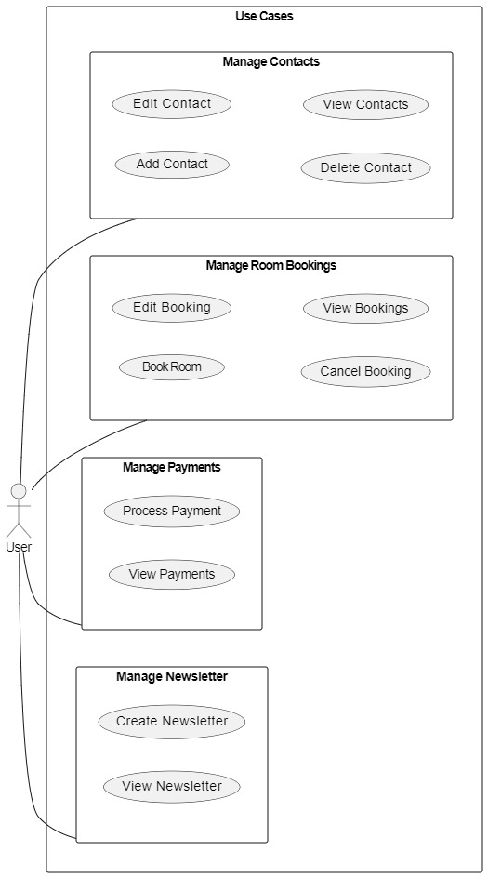

3.2 Data Flow Diagram

Level - 0
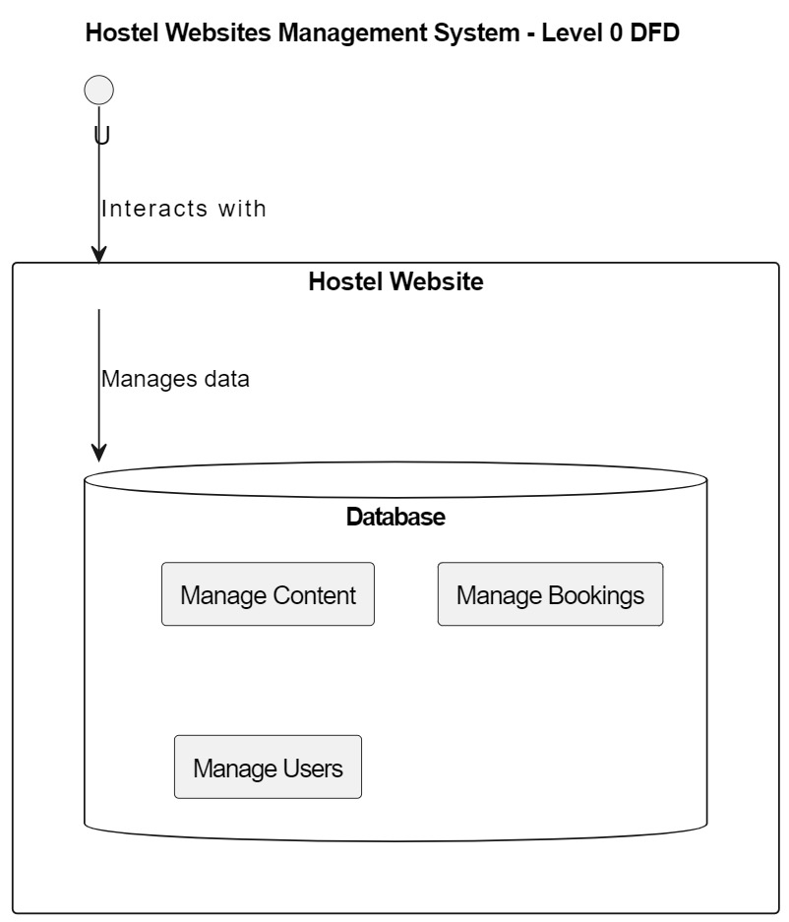
Loyola Men’s Hostel Management System – LEVEL 0 DFD
-

3.2.1 Data Flow Diagram

Level – 1
Loyola Men’s Hostel Management System – LEVEL 1 DFD

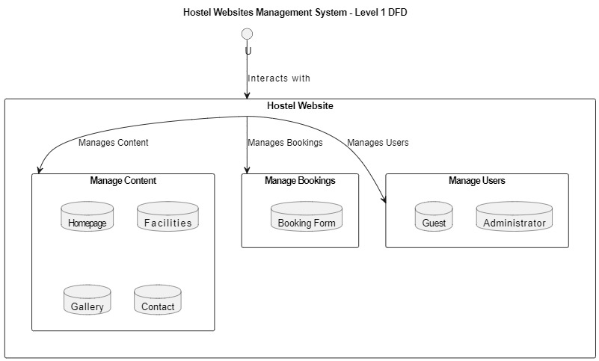

3.3 Class Diagram
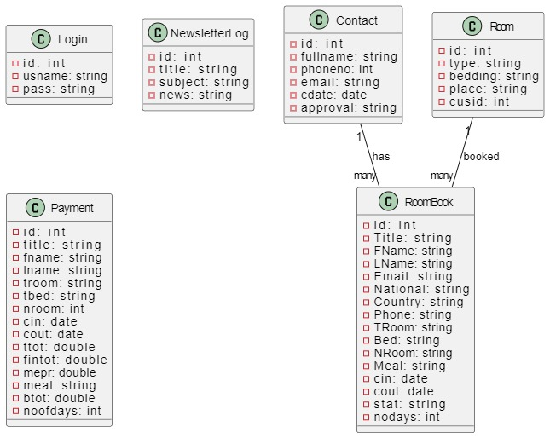

3.4 Sequence Diagram

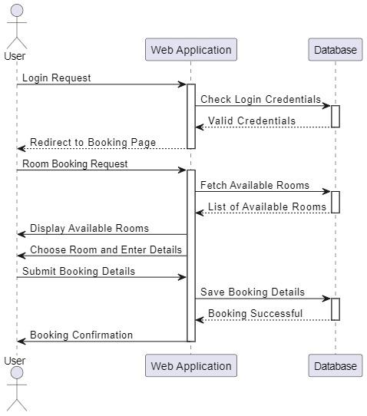

3.5 E.R – Diagram

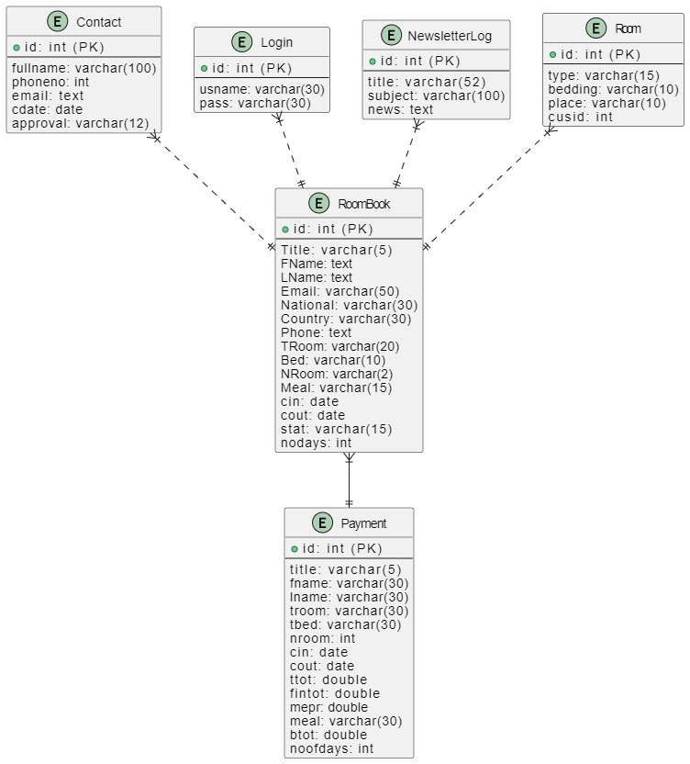

3.6 Database Table Design
Contact Table
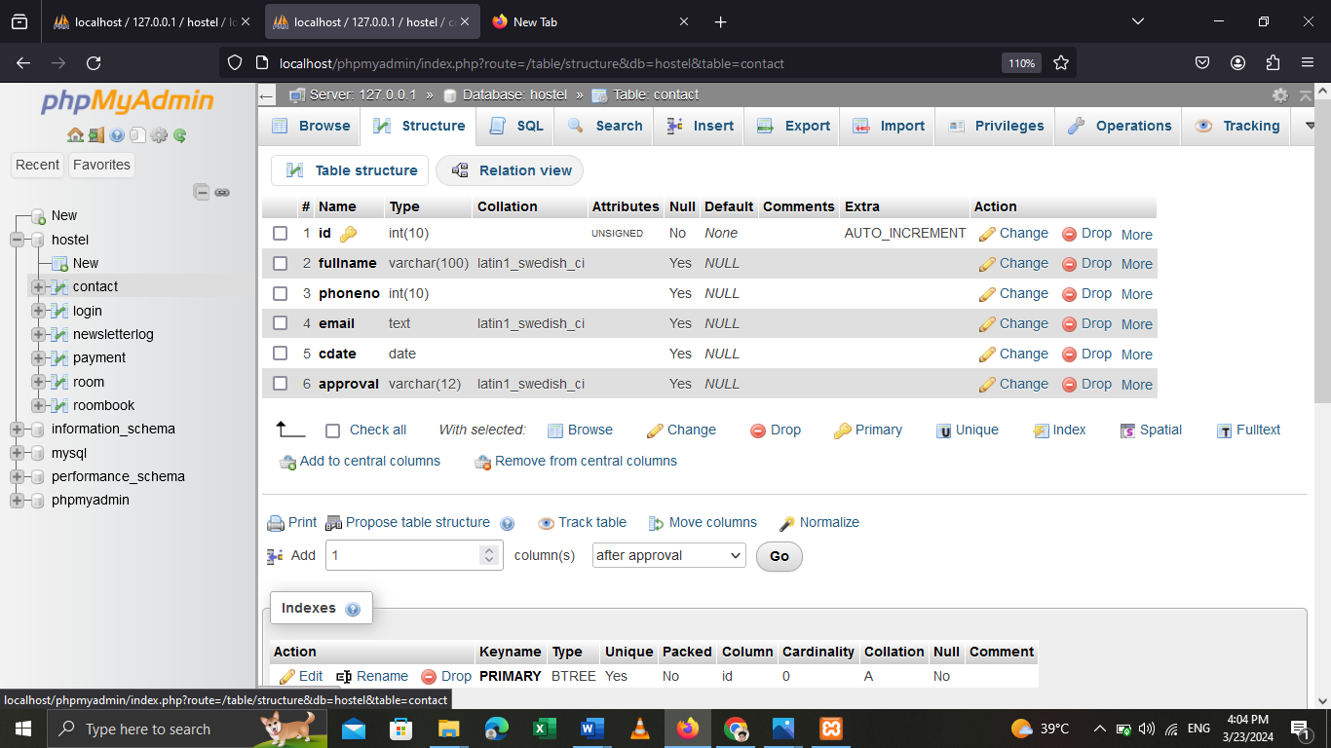
Login Table
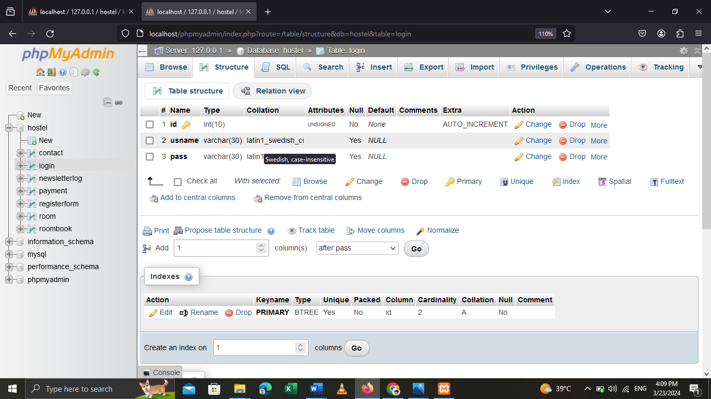
Payment Table

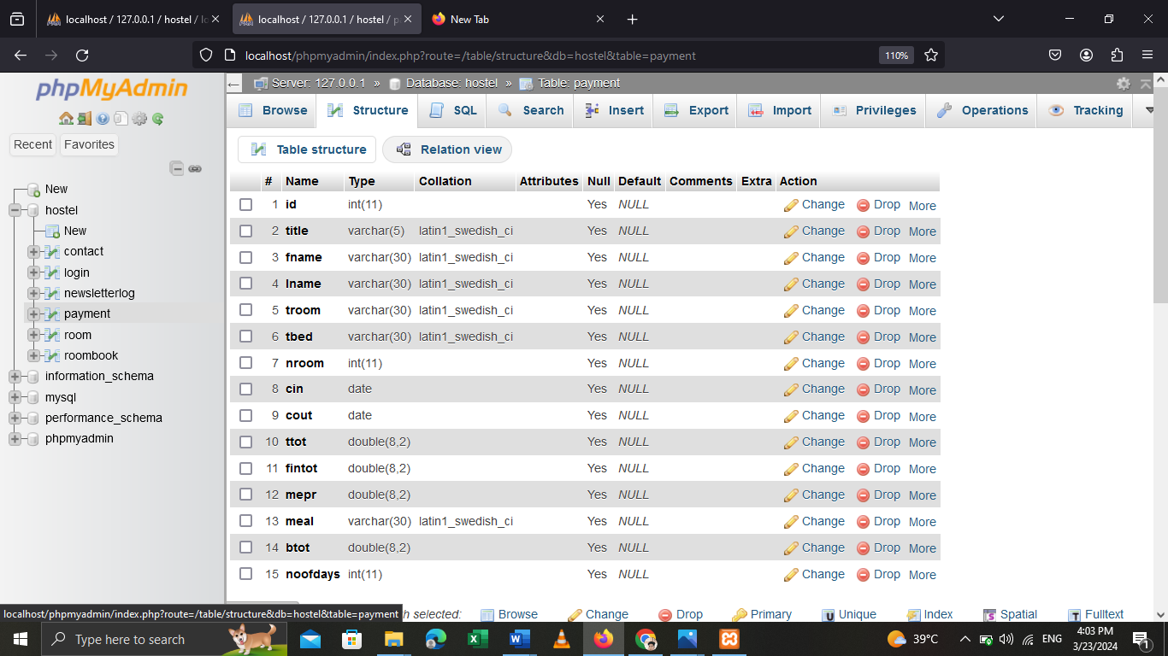

Room Table

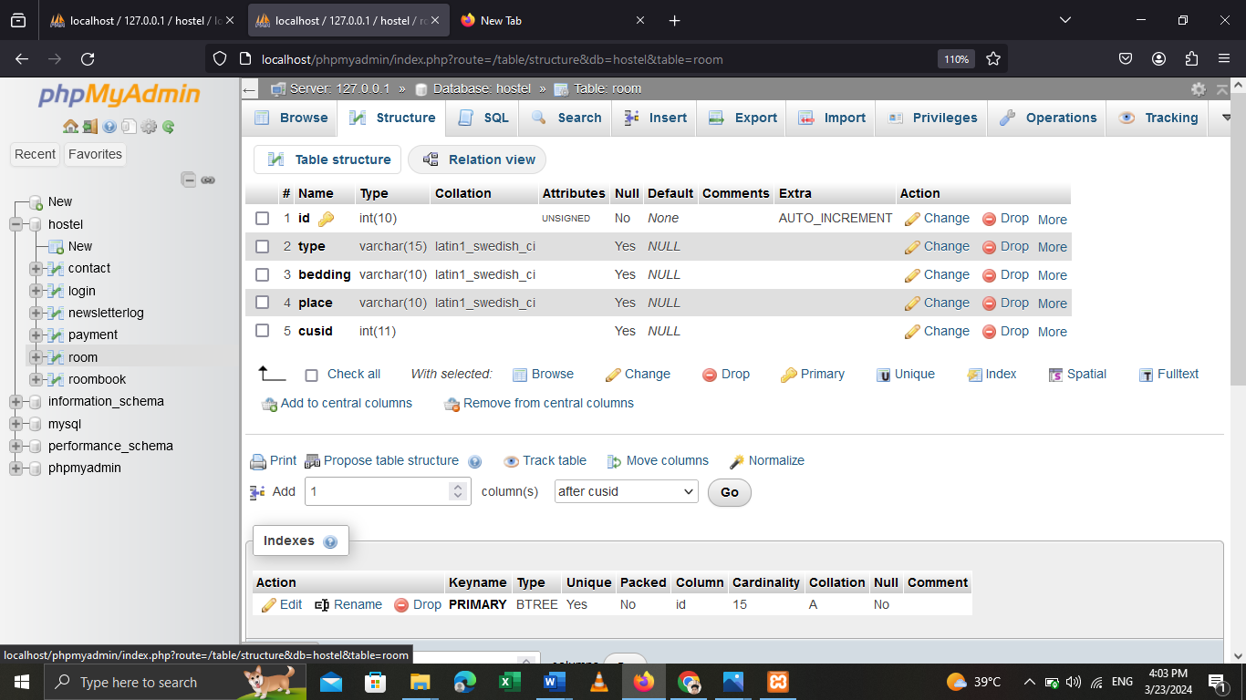

Registerform Table

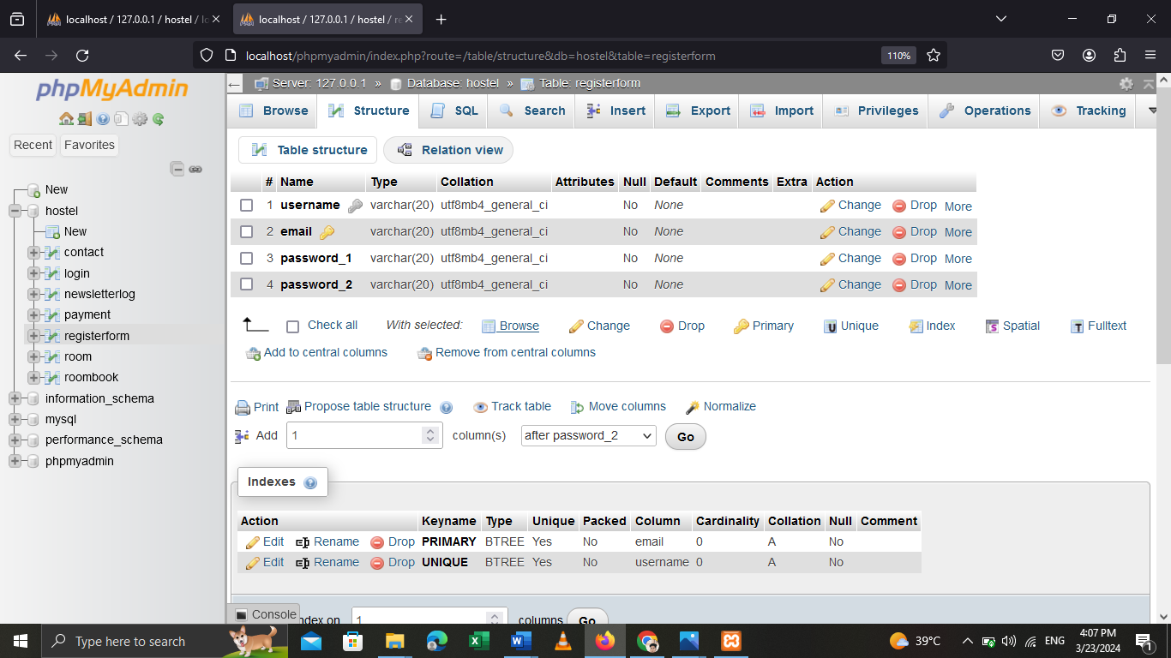

4. TEST CASE

4.1 Unit Test Case
Project Name: Loyola Men’s Hostel Management System
Functionality: Authentication and User Profile Management
Introduction: This document outlines the test cases for the authentication and user profile management functionalities of the Hostel Management System.
Objective:
- Identify the software components to be tested.
- Describe the testing strategy for users.
Scope:
This test strategy applies to the unit testing conducted on the Hostel Management system.
Test Case Design:
The test cases are as follows:
4.2 Module Test Case
1. Login
Objective: To verify that users can log in successfully to the system.
Steps:
- Open the login page.
- Enter valid login credentials (username and password).
- Click on the login button.
- Expected Result: User should be redirected to the dashboard upon successful login.
2. Invalid Login Attempt
Objective: To verify that users cannot log in with invalid credentials.
Steps:
- Open the login page.
- Enter invalid login credentials (incorrect username or password).
- Click on the login button.
- Expected Result: User should see an error message indicating invalid credentials.

3. Forgot Password
Objective: To verify that users can reset their password if forgotten.
Steps:
- Open the forgot password page.
- Enter the registered email address.
- Click on the reset password button.
- Expected Result: User should receive a password reset link via email, allowing them to create a new password.
4. User Profile View
Objective: To verify that users can view their profile information.
Steps:
- Log in to the system.
- Navigate to the user profile page.
- Expected Result: User should be able to view their profile information, including name, contact details, and role.
5. User Profile Update
Objective: To verify that users can update their profile information.
Steps:
- Log in to the system.
- Navigate to the user profile page.
- Update the profile information.
- Click on the update profile button.
- Expected Result: User should receive a confirmation message upon successful profile update.

S.NO | Test Condition | Test Data | Expected Output
1 | Login | Enter The Login Data | Login Successful

5. CONCLUSION
5.1 Appendices
Title of the project : LOYOLA MEN’S HOSTEL MANAGEMENT SYSTEM
Type of project : Web Application
Environment : Offline
Hardware system : 1 TB
Operating system : Windows10
Software Tools : XAMPP, VS Code
Front End : HTML, CSS, JavaScript
Back End : PHP, MySQL
5.2 Source Code
Login.html
<!DOCTYPE html>
<html>
<head>
<title>Registration system PHP and MySQL</title>
<link rel="stylesheet" type="text/css" href="style.css">
</head>
<body>
<div class="header">
<h2>Login</h2>
</div>
<form method="post" action="Untitled 1.png">
<div class="input-group">
<label>Username</label>
<input type="text" name="username"placeholder="Enter a username" required="" >
</div>
<div class="input-group">
<label>Password</label>
<input type="password" name="password" placeholder="Enter a password" required="">
</div>
<div class="input-group">
<button type="submit" class="btn" name="login_user">Login</button>
</div>
<p>
Not yet a member? <a href="register.php">Sign up</a>
</p>
</form>
</body>
</html>
Register.html
<!DOCTYPE html>
<html>
<head>
<title>Registration system PHP and MySQL</title>
<link rel="stylesheet" type="text/css" href="style.css">
</head>
<body>
<div class="header">
<h2>Register</h2>
</div>
<form method="post" action="database.php">
<div class="input-group">
<label>Username</label>
<input type="text" name="username" placeholder="Enter a name"required="">
</div>
<div class="input-group">
<label>Email</label>
<input type="email" name="email" placeholder="Enter email"required="">
</div>
<div class="input-group">
<label>Password</label>
<input type="password" name="password_1"placeholder="password_1"required="">
</div>
<div class="input-group">
<label>Confirm password</label>
<input type="password" name="password_2"placeholder="password_2"required="">
</div>
<div class="input-group">
<button type="submit" class="btn" name="reg_user">Register</button>
</div>
<p>
Already a member? <a href="login.php">Sign in</a>
</p>
</form>
</body>
</html>
Index.php
<?php
include('db.php');
?>
<!DOCTYPE html>
<html lang="en">
<head>
<title>LOYOLA MENS HOSTEL</title>
<!-- for-mobile-apps -->
<meta name="viewport" content="width=device-width, initial-scale=1">
<meta http-equiv="Content-Type" content="text/html; charset=utf-8" />
<meta name="keywords" content="Resort Inn Responsive , Smartphone Compatible web template , Samsung, LG, Sony Ericsson, Motorola web design" />
<script type="application/x-javascript"> addEventListener("load", function() { setTimeout(hideURLbar, 0); }, false);
function hideURLbar(){ window.scrollTo(0,1); }
</script>
<!-- //for-mobile-apps -->
<link href="css/bootstrap.css" rel="stylesheet" type="text/css" media="all" />
<link href="css/font-awesome.css" rel="stylesheet">
<link rel="stylesheet" href="css/chocolat.css" type="text/css" media="screen">
<link href="css/easy-responsive-tabs.css" rel='stylesheet' type='text/css'/>
<link rel="stylesheet" href="css/flexslider.css" type="text/css" media="screen" property="" />
<link rel="stylesheet" href="css/jquery-ui.css" />
<link href="css/style.css" rel="stylesheet" type="text/css" media="all" />
<script type="text/javascript" src="js/modernizr-2.6.2.min.js"></script>
<!--fonts-->
<link href="//fonts.googleapis.com/css?family=Oswald:300,400,700" rel="stylesheet">
<link href="//fonts.googleapis.com/css?family=Federo" rel="stylesheet">
<link href="//fonts.googleapis.com/css?family=Lato:300,400,700,900" rel="stylesheet">
<!--//fonts-->
</head>
<body>
<!-- header -->
<div class="banner-top">
<div class="social-bnr-agileits">
<ul class="social-icons3">
<li><a href="https://www.facebook.com/" class="fa fa-facebook icon-border facebook"></a></li>
<li><a href="https://twitter.com/" class="fa fa-twitter icon-border twitter"></a></li>
<li><a href="https://plus.google.com/u/0/" class="fa fa-google-plus icon-border googleplus"></a></li>
</ul>
</div>
<div class="contact-bnr-w3-agile">
<ul>
<li><i class="fa fa-envelope" aria-hidden="true"></i><a href="mailto:info@example.com">INFO@LOYOLA MENS HOSTEL.COM </a></li>
<li><i class="fa fa-phone" aria-hidden="true"></i>+91 9384496450</li>
<li class="s-bar">
<div class="search">
<input class="search_box" type="checkbox" id="search_box">
<label class="icon-search" for="search_box"><span class="glyphicon glyphicon-search" aria-hidden="true"></span></label>
<div class="search_form">
<form action="#" method="post">
<input type="search" name="Search" placeholder=" " required=" " />
<input type="submit" value="Search">
</form>
</div>
</div>
</li>
</ul>
</div>
<div class="clearfix"></div>
</div>
<div class="w3_navigation">
<div class="container">
<nav class="navbar navbar-default">
<div class="navbar-header navbar-left">
<button type="button" class="navbar-toggle collapsed" data-toggle="collapse" data-target="#bs-example-navbar-collapse-1">
<span class="sr-only">Toggle navigation</span>
<span class="icon-bar"></span>
<span class="icon-bar"></span>
<span class="icon-bar"></span>
</button>
<h1><a class="navbar-brand" href="index.php">LOYOLA<span>MEN'S</span><p class="logo_w3l_agile_caption">Your Dreamy HOSTEL</p></a></h1>
</div>
<!-- Collect the nav links, forms, and other content for toggling -->
<div class="collapse navbar-collapse navbar-right" id="bs-example-navbar-collapse-1">
<nav class="menu menu--iris">
<ul class="nav navbar-nav menu__list">
<li class="menu__item menu__item--current"><a href="" class="menu__link">Home</a></li>
<li class="menu__item"><a href="#about" class="menu__link scroll">About</a></li>
<li class="menu__item"><a href="#team" class="menu__link scroll">Team</a></li>
<li class="menu__item"><a href="#gallery" class="menu__link scroll">Gallery</a></li>
<li class="menu__item"><a href="#rooms" class="menu__link scroll">Rooms</a></li>
<li class="menu__item"><a href="#contact" class="menu__link scroll">Contact Us</a></li>
<li class="menu__item"><a href="login.php"><button class="btn">Student Login</button></a></li>
</ul>
</nav>
</div>
</nav>

</div>
</div>
<!-- //header -->
<!-- banner -->
<div id="home" class="w3ls-banner">
<!-- banner-text -->
<div class="slider">
<div class="callbacks_container">
<ul class="rslides callbacks callbacks1" id="slider4">
<li>
<div class="w3layouts-banner-top">
<div class="container">
<div class="agileits-banner-info">
<h4>LOYOLA MENS HOSTEL</h4>
<h3>We know what you love</h3>
<p>Welcome to our Hostel</p>
<div class="agileits_w3layouts_more menu__item">
<a href="#" class="menu__link" data-toggle="modal" data-target="#myModal">Learn More</a>
</div>
</div>
</div>
</div>
</li>
<li>
<div class="w3layouts-banner-top w3layouts-banner-top1">
<div class="container">
<div class="agileits-banner-info">
<h4>LOYOLA MENS HOSTEL</h4>
<h3>Stay with yours friends</h3>
<p>Come & enjoy precious moment with us</p>
<div class="agileits_w3layouts_more menu__item">
<a href="#" class="menu__link" data-toggle="modal" data-target="#myModal">Learn More</a>
</div>
</div>
</div>
</div>
</li>
<li>
<div class="w3layouts-banner-top w3layouts-banner-top2">
<div class="container">
<div class="agileits-banner-info">
<h4>LOYOLA MENS HOSTEL</h4>
<h3>want luxurious hostel</h3>
<p>Get accommodation today</p>
<div class="agileits_w3layouts_more menu__item">
<a href="#" class="menu__link" data-toggle="modal" data-target="#myModal">Learn More</a>
</div>
</div>
</div>
</div>
</li>
</ul>
</div>
<div class="clearfix"></div>
<!--banner Slider starts Here-->
</div>
<div class="thim-click-to-bottom">
<a href="#about" class="scroll">
<i class="fa fa-long-arrow-down" aria-hidden="true"></i>
</a>
</div>
</div>
<! -- //banner -->
<!--//Header-->
<!-- //Modal1 -->
<div class="modal fade" id="myModal" tabindex="-1" role="dialog">
<!-- Modal1 -->
<div class="modal-dialog">
<!-- Modal content-->
<div class="modal-content">
<div class="modal-header">
<button type="button" class="close" data-dismiss="modal">&times;</button>
<h4>LOYOLA <span>HOSTEL</span></h4>
<img src="images/1.jpg" alt=" " class="img-responsive">
<h5>We know what you love</h5>
<p>Providing students unique and enchanting views from their rooms with its exceptional amenities, makes Star Hostel one of bests in its kind.Try our food menu, awesome services and friendly staff while you are here.</p>
</div>
</div>
</div>
</div>
<!-- //Modal1 -->
<div id="availability-agileits">
<div class="col-md-12 book-form-left-w3layouts">
<a href="admin/reservation.php"><h2>HOSTEL RESERVATION</h2></a>
</div>
<div class="clearfix"></div>
</div>
<!-- banner-bottom -->
<div class="banner-bottom">
<div class="container">
<div class="agileits_banner_bottom">
<h3><span>Experience a good stay, enjoy fantastic offers</span> Find our friendly welcoming reception</h3>
</div>
<div class="w3ls_banner_bottom_grids">
<ul class="cbp-ig-grid">
<li>
<div class="w3_grid_effect">
<span class="cbp-ig-icon w3_road"></span>
<h4 class="cbp-ig-title">MASTER ROOMS</h4>
<span class="cbp-ig-category">LOYOLA MENS HOSTEL</span>
</div>
</li>
<li>
<div class="w3_grid_effect">
<span class="cbp-ig-icon w3_cube"></span>
<h4 class="cbp-ig-title">VIEW BALCONY</h4>
<span class="cbp-ig-category">LOYOLA MENS HOSTEL</span>
</div>
</li>
<li>
<div class="w3_grid_effect">
<span class="cbp-ig-icon w3_users"></span>
<h4 class="cbp-ig-title">EVENING CAFE TIME</h4>
<span class="cbp-ig-category">LOYOLA MENS HOSTEL</span>
</div>
</li>
<li>
<div class="w3_grid_effect">
<span class="cbp-ig-icon w3_ticket"></span>
<h4 class="cbp-ig-title">WIFI COVERAGE</h4>
<span class="cbp-ig-category">LOYOLA MENS HOSTEL</span>
</div>
</li>
</ul>
</div>
</div>
</div>
<!-- //banner-bottom -->
<!-- /about -->
<div class="about-wthree" id="about">
<div class="container">
<div class="ab-w3l-spa">
<h3 class="title-w3-agileits title-black-wthree">LOYOLA MENS HOSTEL</h3>
<p class="about-para-w3ls">Hostel life: where strangers become friends and every day is an adventure.In a hostel, you don't just share a room; you share stories, laughter, and memories.</p>
<img src="images/about.JPG" class="img-responsive" alt="Hair Salon">
<div class="w3l-slider-img">
<img src="images/about.JPG" class="img-responsive" alt="Hair Salon">
</div>
<div class="w3ls-info-about">
<h4>We are love the Loyola Men's!</h4>
<p>Lorem ipsum dolor sit amet, ut magna aliqua. </p>
</div>
</div>
<div class="clearfix"></div>
</div>
</div>
<!-- //about -->
<!--sevices-->
<div class="advantages">
<div class="container">
<div class="advantages-main">
<h3 class="title-w3-agileits">Our Facility</h3>
<div class="advantage-bottom">
<div class="col-md-6 advantage-grid left-w3ls wow bounceInLeft" data-wow-delay="0.3s">
<div class="advantage-block ">
<i class="fa fa-credit-card" aria-hidden="true"></i>
<h4>Stay First, Pay After! </h4>
<p>Sleep is optional, but fun is mandatory in hostel life! ...</p>
<p><i class="fa fa-check" aria-hidden="true"></i>Decorated room, proper air conditioned</p>
<p><i class="fa fa-check" aria-hidden="true"></i>Private ROOMS</p>
</div>
</div>
<div class="col-md-6 advantage-grid right-w3ls wow zoomIn" data-wow-delay="0.3s">
<div class="advantage-block">
<i class="fa fa-clock-o" aria-hidden="true"></i>
<h4>24 Hour Hostel</h4>
<p>Sleep is optional, but fun is mandatory in hostel life.</p>
<p><i class="fa fa-check" aria-hidden="true"></i>24 hours Hostel service</p>
<p><i class="fa fa-check" aria-hidden="true"></i>24-hour Water service</p>
</div>
</div>
<div class="clearfix"></div>
</div>
</div>
</div>
</div>
<!--//sevices-->
<!-- team -->
<div class="team" id="team">
<div class="container">
<h3 class="title-w3-agileits title-black-wthree">Meet Our Team</h3>
<div id="horizontalTab">
<ul class="resp-tabs-list">
<li>
<img src="images/teams1.jpg" alt=" " class="img-responsive" />
</li>
<li>
<img src="images/teams2.jpg" alt=" " class="img-responsive" />
</li>
<li>
<img src="images/teams3.jpg" alt=" " class="img-responsive" />
</li>
<li>
<img src="images/teams4.jpg" alt=" " class="img-responsive" />
</li>
</ul>
<div class="resp-tabs-container">
<div class="tab1">
<div class="col-md-6 team-img-w3-agile">
</div>
<div class="col-md-6 team-Info-agileits">
<h4>Arokiya Alton</h4>
<span>Director of Loyola Mens Hostel</span>
<p> Best things that's happened this year? maybe hostel it was a great experience i loved it</p>
<div class="social-bnr-agileits footer-icons-agileinfo">
<ul class="social-icons3">
<li><a href="#" class="fa fa-facebook icon-border facebook"></a></li>
<li><a href="#" class="fa fa-twitter icon-border twitter"></a></li>
<li><a href="#" class="fa fa-google-plus icon-border googleplus"></a></li>
<li><a href="#" class="fa fa-rss icon-border rss"></a></li>
</ul>
</div>
</div>
<div class="clearfix"></div>
</div>
<div class="tab2">
<div class="col-md-6 team-img-w3-agile">
</div>
<div class="col-md-6 team-Info-agileits">
<h4>philomen</h4>
<span>Ass.Director</span>
<p>The first assistant director is just so important that the choice of that person is critical to the movie.</p>
<div class="social-bnr-agileits footer-icons-agileinfo">
<ul class="social-icons3">
<li><a href="#" class="fa fa-facebook icon-border facebook"></a></li>
<li><a href="#" class="fa fa-twitter icon-border twitter"></a></li>
<li><a href="#" class="fa fa-google-plus icon-border googleplus"></a></li>
<li><a href="#" class="fa fa-rss icon-border rss"></a></li>
</ul>
</div>
</div>
<div class="clearfix"></div>
</div>
<div class="tab3">
<div class="col-md-6 team-img-w3-agile">
</div>
<div class="col-md-6 team-Info-agileits">
<h4>Prem kumar</h4>
<span>ASS.Director</span>
<p>The first assistant director is just so important that the choice of that person is critical to the movie.</p>
<div class="social-bnr-agileits footer-icons-agileinfo">
<ul class="social-icons3">
<li><a href="#" class="fa fa-facebook icon-border facebook"></a></li>
<li><a href="#" class="fa fa-twitter icon-border twitter"></a></li>
<li><a href="#" class="fa fa-google-plus icon-border googleplus"></a></li>
<li><a href="#" class="fa fa-rss icon-border rss"></a></li>
</ul>
</div>
</div>
<div class="clearfix"></div>
</div>
<div class="tab4">
<div class="col-md-6 team-img-w3-agile">
</div>
<div class="col-md-6 team-Info-agileits">
<h4>Amalraji</h4>
<span>ASS.Director</span>
<p>The first assistant director is just so important that the choice of that person is critical to the movie.</p>
<div class="social-bnr-agileits footer-icons-agileinfo">
<ul class="social-icons3">
<li><a href="#" class="fa fa-facebook icon-border facebook"></a></li>
<li><a href="#" class="fa fa-twitter icon-border twitter"></a></li>
<li><a href="#" class="fa fa-google-plus icon-border googleplus"></a></li>
<li><a href="#" class="fa fa-rss icon-border rss"></a></li>
</ul>
</div>
</div>
<div class="clearfix"></div>
</div>
</div>
</div>
</div>
</div>
<!-- //team -->
<!-- Gallery -->
<section class="portfolio-w3ls" id="gallery">
<h3 class="title-w3-agileits title-black-wthree">Our Gallery</h3>
<div class="col-md-3 gallery-grid gallery1">
<a href="images/g1.jpg" class="swipebox"><img src="images/g1.jpg" class="img-responsive" alt="/">
<div class="textbox">
<h4>LOYOLA MENS HOSTEL</h4>
<p><i class="fa fa-picture-o" aria-hidden="true"></i></p>
</div>
</a>
</div>
<div class="col-md-3 gallery-grid gallery1">
<a href="images/g2.jpg" class="swipebox"><img src="images/g2.jpg" class="img-responsive" alt="/">
<div class="textbox">
<h4>LOYOLA MENS HOSTEL</h4>
<p><i class="fa fa-picture-o" aria-hidden="true"></i></p>
</div>
</a>
</div>
<div class="col-md-3 gallery-grid gallery1">
<a href="images/g3.jpg" class="swipebox"><img src="images/g3.jpg" class="img-responsive" alt="/">
<div class="textbox">
<h4>LOYOLA MENS HOSTEL</h4>
<p><i class="fa fa-picture-o" aria-hidden="true"></i></p>
</div>
</a>
</div>
<div class="col-md-3 gallery-grid gallery1">
<a href="images/g4.jpg" class="swipebox"><img src="images/g4.jpg" class="img-responsive" alt="/">
<div class="textbox">
<h4>LOYOLA MENS HOSTEL</h4>
<p><i class="fa fa-picture-o" aria-hidden="true"></i></p>
</div>
</a>
</div>
<div class="col-md-3 gallery-grid gallery1">
<a href="images/g5.jpg" class="swipebox"><img src="images/g5.jpg" class="img-responsive" alt="/">
<div class="textbox">
<h4>LOYOLA MENS HOSTEL</h4>
<p><i class="fa fa-picture-o" aria-hidden="true"></i></p>
</div>
</a>
</div>
<div class="col-md-3 gallery-grid gallery1">
<a href="images/g6.jpg" class="swipebox"><img src="images/g6.jpg" class="img-responsive" alt="/">
<div class="textbox">
<h4>LOYOLA MENS HOSTEL</h4>
<p><i class="fa fa-picture-o" aria-hidden="true"></i></p>
</div>
</a>
</div>
<div class="col-md-3 gallery-grid gallery1">
<a href="images/g6.jpg" class="swipebox"><img src="images/g7.jpg" class="img-responsive" alt="/">
<div class="textbox">
<h4>LOYOLA MENS HOSTEL</h4>
<p><i class="fa fa-picture-o" aria-hidden="true"></i></p>
</div>
</a>
</div>
<div class="col-md-3 gallery-grid gallery1">
<a href="images/g6.jpg" class="swipebox"><img src="images/g8.jpg" class="img-responsive" alt="/">
<div class="textbox">
<h4>LOYOLA MENS HOSTEL</h4>
<p><i class="fa fa-picture-o" aria-hidden="true"></i></p>
</div>
</a>
</div>
<div class="col-md-3 gallery-grid gallery1">
<a href="images/g9.jpg" class="swipebox"><img src="images/g9.jpg" class="img-responsive" alt="/">
<div class="textbox">
<h4>LOYOLA MENS HOSTEL</h4>
<p><i class="fa fa-picture-o" aria-hidden="true"></i></p>
</div>
</a>
</div>
<div class="col-md-3 gallery-grid gallery1">
<a href="images/g10.jpg" class="swipebox"><img src="images/g10.jpg" class="img-responsive" alt="/">
<div class="textbox">
<h4>LOYOLA MENS HOSTEL</h4>
<p><i class="fa fa-picture-o" aria-hidden="true"></i></p>
</div>
</a>
</div>
<div class="col-md-3 gallery-grid gallery1">
<a href="images/g4.jpg" class="swipebox"><img src="images/g4.jpg" class="img-responsive" alt="/">
<div class="textbox">
<h4>LOYOLA MENS HOSTEL</h4>
<p><i class="fa fa-picture-o" aria-hidden="true"></i></p>
</div>
</a>
</div>
<div class="col-md-3 gallery-grid gallery1">
<a href="images/g2.jpg" class="swipebox"><img src="images/g2.jpg" class="img-responsive" alt="/">
<div class="textbox">
<h4>LOYOLA MENS HOSTEL</h4>
<p><i class="fa fa-picture-o" aria-hidden="true"></i></p>
</div>
</a>
</div>
<div class="clearfix"></div>
</section>
<!-- //gallery -->
<!-- rooms & rates -->
<div class="plans-section" id="rooms">
<div class="container">
<h3 class="title-w3-agileits title-black-wthree">Hostel Rooms</h3>
<div class="priceing-table-main">
<div class="col-md-3 price-grid">
<div class="price-block agile">
<div class="price-gd-top">
<img src="images/r1.jpg" alt=" " class="img-responsive" />
<h4>Function Time</h4>
</div>
<div class="price-gd-bottom">
<div class="price-list">
<ul>
<li><i class="fa fa-star" aria-hidden="true"></i></li>
<li><i class="fa fa-star" aria-hidden="true"></i></li>
<li><i class="fa fa-star" aria-hidden="true"></i></li>
<li><i class="fa fa-star" aria-hidden="true"></i></li>
<li><i class="fa fa-star-o" aria-hidden="true"></i></li>

</ul>
</div>
<div class="price-selet">
<a href="admin/reservation.php" >Book Now</a>
</div>
</div>
</div>
</div>
<div class="col-md-3 price-grid ">
<div class="price-block agile">
<div class="price-gd-top">
<img src="images/r2.jpg" alt=" " class="img-responsive" />
<h4>Hostel Openstage</h4>
</div>
<div class="price-gd-bottom">
<div class="price-list">
<ul>
<li><i class="fa fa-star" aria-hidden="true"></i></li>
<li><i class="fa fa-star" aria-hidden="true"></i></li>
<li><i class="fa fa-star" aria-hidden="true"></i></li>
<li><i class="fa fa-star" aria-hidden="true"></i></li>
<li><i class="fa fa-star-o" aria-hidden="true"></i></li>
</ul>
</div>
<div class="price-selet">
<a href="admin/reservation.php" >Book Now</a>
</div>
</div>
</div>
</div>
<div class="col-md-3 price-grid lost">
<div class="price-block agile">
<div class="price-gd-top">
<img src="images/r3.jpg" alt=" " class="img-responsive" />
<h4>Hostel Playround</h4>
</div>
<div class="price-gd-bottom">
<div class="price-list">
<ul>
<li><i class="fa fa-star" aria-hidden="true"></i></li>
<li><i class="fa fa-star" aria-hidden="true"></i></li>
<li><i class="fa fa-star" aria-hidden="true"></i></li>
<li><i class="fa fa-star-o" aria-hidden="true"></i></li>
<li><i class="fa fa-star-o" aria-hidden="true"></i></li>
</ul>
</div>
<div class="price-selet">
<a href="admin/reservation.php" >Book Now</a>
</div>
</div>
</div>
</div>
<div class="col-md-3 price-grid wthree lost">
<div class="price-block agile">
<div class="price-gd-top ">
<img src="images/r4.jpg" alt=" " class="img-responsive" />
<h4>Hostel Mess</h4>
</div>
<div class="price-gd-bottom">
<div class="price-list">
<ul>
<li><i class="fa fa-star" aria-hidden="true"></i></li>
<li><i class="fa fa-star" aria-hidden="true"></i></li>
<li><i class="fa fa-star-o" aria-hidden="true"></i></li>
<li><i class="fa fa-star-o" aria-hidden="true"></i></li>
<li><i class="fa fa-star-o" aria-hidden="true"></i></li>
</ul>
</div>
<div class="price-selet">
<a href="admin/reservation.php" >Book Now</a>
</div>
</div>
</div>
</div>
<div class="clearfix"></div>
</div>
</div>
</div>
<!--// rooms & rates -->
<!-- visitors -->
<div class="w3l-visitors-agile" >
<div class="container">
<h3 class="title-w3-agileits title-black-wthree">We Are visit For Other Places</h3>
</div>
<div class="w3layouts_work_grids">
<section class="slider">
<div class="flexslider">
<ul class="slides">
<li>
<div class="w3layouts_work_grid_left">
<img src="images/5.jpg" alt=" " class="img-responsive" />
<div class="w3layouts_work_grid_left_pos">
<img src="images/c1.jpg" alt=" " class="img-responsive" />
</div>
</div>
<div class="w3layouts_work_grid_right">
<h4>
<i class="fa fa-star" aria-hidden="true"></i>
<i class="fa fa-star" aria-hidden="true"></i>
<i class="fa fa-star" aria-hidden="true"></i>
<i class="fa fa-star" aria-hidden="true"></i>
<i class="fa fa-star" aria-hidden="true"></i>
Way to cross
</h4>
<p>Sin was conquered on the cross. [Christ's] death is the foundation of our hope, the promise of our triumph!”
“The cross is the suffering love of God bearing the guilt of man's sin, which alone is able to melt the sinner's heart and bring him to repentance for salvation.”
“The ground is level at the foot of the cross.” </p>
<h5>With Lcv Family Members</h5>
<p>Vettavalam</p>
</div>
<div class="clearfix"></div>
</li>
<li>
<div class="w3layouts_work_grid_left">
<img src="images/5.jpg" alt=" " class="img-responsive" />
<div class="w3layouts_work_grid_left_pos">
<img src="images/c2.jpg" alt=" " class="img-responsive" />
</div>
</div>
<div class="w3layouts_work_grid_right">
<h4>
<i class="fa fa-star" aria-hidden="true"></i>
<i class="fa fa-star" aria-hidden="true"></i>
<i class="fa fa-star" aria-hidden="true"></i>
<i class="fa fa-star" aria-hidden="true"></i>
<i class="fa fa-star-o" aria-hidden="true"></i>
Yearly once take a group photo
</h4>
<p>Find a group of people who challenge and inspire you spend a lot of time with them, and it will change your life </p>
<h5>LMH</h5>
<p>LOYOLA COLLEGE</p>
</div>
<div class="clearfix"></div>
</li>
<li>
<div class="w3layouts_work_grid_left">
<img src="images/5.jpg" alt=" " class="img-responsive" />
<div class="w3layouts_work_grid_left_pos">
<img src="images/c3.jpg" alt=" " class="img-responsive" />
</div>
</div>
<div class="w3layouts_work_grid_right">
<h4>
<i class="fa fa-star" aria-hidden="true"></i>
<i class="fa fa-star" aria-hidden="true"></i>
<i class="fa fa-star" aria-hidden="true"></i>
<i class="fa fa-star" aria-hidden="true"></i>
<i class="fa fa-star-o" aria-hidden="true"></i>
YEARLY ONCE GO TO CHURCH
</h4>
<p>BE strong and courageous do not fear or be in dread of them for it
is the lord your god who goes with you ,
he wil not leave you or forsake you</p>
<h5>LMH</h5>
<p>CHURCH IN VETTAVALAM</p>
</div>
<div class="clearfix"></div>
</li>
<li>
<div class="w3layouts_work_grid_left">
<img src="images/5.jpg" alt=" " class="img-responsive" />
<div class="w3layouts_work_grid_left_pos">
<img src="images/c4.jpg" alt=" " class="img-responsive" />
</div>
</div>
<div class="w3layouts_work_grid_right">
<h4>
<i class="fa fa-star" aria-hidden="true"></i>
<i class="fa fa-star" aria-hidden="true"></i>
<i class="fa fa-star" aria-hidden="true"></i>
<i class="fa fa-star-o" aria-hidden="true"></i>
<i class="fa fa-star-o" aria-hidden="true"></i>
24/7 CCTV CAMERAS FIXED
</h4>
<p>SURVEILLANCE technology has seen an incredible level of evolution.
that only makes it far more advanced but afforadable ,
and available to everyone </p>
<h5>LOYOLA MEN'S</h5>
<p>HOSTEL</p>
</div>
<div class="clearfix"></div>
</li>
</ul>
</div>
</section>
</div>
</div>
<!-- visitors -->
<!-- contact -->
<section class="contact-w3ls" id="contact">
<div class="container">
<div class="col-lg-6 col-md-6 col-sm-6 contact-w3-agile2" data-aos="flip-left">
<div class="contact-agileits">
<h4>Contact Us</h4>
<p class="contact-agile2">Sign Up For Our News Letters</p>
<form method="post" name="sentMessage" id="contactForm" >
<div class="control-group form-group">

<label class="contact-p1">Full Name:</label>
<input type="text" class="form-control" name="name" id="name" required >
<p class="help-block"></p>
</div>
<div class="control-group form-group">
<label class="contact-p1">Phone Number:</label>
<input type="tel" class="form-control" name="phone" id="phone" required >
<p class="help-block"></p>

</div>
<div class="control-group form-group">
<label class="contact-p1">Email Address:</label>
<input type="email" class="form-control" name="email" id="email" required >
<p class="help-block"></p>
</div>
<input type="submit" name="sub" value="Send Now" class="btn btn-primary">
</form>
<?php
if(isset($_POST['sub']))
{
$name =$_POST['name'];
$phone = $_POST['phone'];
$email = $_POST['email'];
$approval = "Not Allowed";
$sql = "INSERT INTO `contact`(`fullname`, `phoneno`, `email`,`cdate`,`approval`) VALUES ('$name','$phone','$email',now(),'$approval')" ;
if(mysqli_query($con,$sql))
echo"OK";
}
?>
</div>
</div>
<div class="col-lg-6 col-md-6 col-sm-6 contact-w3-agile1" data-aos="flip-right">
<h4>Connect With Us</h4>
<p class="contact-agile1"><strong>Phone :</strong>+91 9384496450</p>
<p class="contact-agile1"><strong>Email :</strong><a href="mailto:name@example.com">INFO@LOYOLA MENS HOSTEL.COM</a></p>
<p class="contact-agile1"><strong>Address :</strong> Loyola College Vettavalam-606754,Tiruvannamalai-dt</p>
<div class="social-bnr-agileits footer-icons-agileinfo">
<ul class="social-icons3">
<li><a href="#" class="fa fa-facebook icon-border facebook"></a></li>
<li><a href="#" class="fa fa-twitter icon-border twitter"></a></li>
<li><a href="#" class="fa fa-google-plus icon-border googleplus"></a></li>
</ul>
</div>
<iframe src="46FG+8QJ, Vettavalam Rd, Anna Nagar, Vettavalam, Tamil Nadu 60675446FG+8QJ, Vettavalam Rd, Anna Nagar, Vettavalam, Tamil Nadu 606754" ></iframe>
</div>
<div class="clearfix"></div>
</div>
</section>
<!-- /contact -->
<div class="copy">
<p>© 2024 LOYOLA MENS HOSTEL. All Rights Reserved | Design by <a href="index.php">LOYOLA MENS HOSTEL</a></p>
</div>
<!--/footer -->
<!-- js -->
<script type="text/javascript" src="js/jquery-2.1.4.min.js"></script>
<!-- contact form -->
<script src="js/jqBootstrapValidation.js"></script>

<!-- /contact form -->
<!-- Calendar -->
<script src="js/jquery-ui.js"></script>
<script>
$(function() {
$( "#datepicker,#datepicker1,#datepicker2,#datepicker3" ).datepicker();
});
</script>
<!-- //Calendar -->
<!-- gallery popup -->
<link rel="stylesheet" href="css/swipebox.css">
<script src="js/jquery.swipebox.min.js"></script>
<script type="text/javascript">
jQuery(function($) {
$(".swipebox").swipebox();
});
</script>
<!-- //gallery popup -->
<!-- start-smoth-scrolling -->
<script type="text/javascript" src="js/move-top.js"></script>
<script type="text/javascript" src="js/easing.js"></script>
<script type="text/javascript">
jQuery(document).ready(function($) {
$(".scroll").click(function(event){
event.preventDefault();
$('html,body').animate({scrollTop:$(this.hash).offset().top},1000);
});
});
</script>
<!-- start-smoth-scrolling -->
<!-- flexSlider -->
<script defer src="js/jquery.flexslider.js"></script>
<script type="text/javascript">
$(window).load(function(){
$('.flexslider').flexslider({
animation: "slide",
start: function(slider){
$('body').removeClass('loading');
}
});
});
</script>
<!-- //flexSlider -->
<script src="js/responsiveslides.min.js"></script>
<script>
// You can also use "$(window).load(function() {"
$(function () {
// Slideshow 4
$("#slider4").responsiveSlides({
auto: true,
pager:true,
nav:false,
speed: 500,
namespace: "callbacks",
before: function () {
$('.events').append("<li>before event fired.</li>");
},
after: function () {
$('.events').append("<li>after event fired.</li>");
}
});
});
</script>
<!--search-bar-->
<script src="js/main.js"></script>
<!--//search-bar-->
<!--tabs-->
<script src="js/easy-responsive-tabs.js"></script>
<script>
$(document).ready(function () {
$('#horizontalTab').easyResponsiveTabs({
type: 'default', //Types: default, vertical, accordion
width: 'auto', //auto or any width like 600px
fit: true, // 100% fit in a container
closed: 'accordion', // Start closed if in accordion view
activate: function(event) { // Callback function if tab is switched
var $tab = $(this);
var $info = $('#tabInfo');
var $name = $('span', $info);
$name.text($tab.text());
$info.show();
}
});
$('#verticalTab').easyResponsiveTabs({
type: 'vertical',
width: 'auto',
fit: true
});
});
</script>
<!--//tabs-->
<!-- smooth scrolling -->
<script type="text/javascript">
$(document).ready(function() {
/*
var defaults = {
containerID: 'toTop', // fading element id
containerHoverID: 'toTopHover', // fading element hover id
scrollSpeed: 1200,
easingType: 'linear'
};
*/
$().UItoTop({ easingType: 'easeOutQuart' });
});
</script>
<div class="arr-w3ls">
<a href="#home" id="toTop" style="display: block;"><span id="toTopHover" style="opacity: 1;"></span></a>
</div>
<!-- //smooth scrolling -->
<script type="text/javascript" src="js/bootstrap-3.1.1.min.js"></script>
</body>
</html>
SQL:
-- phpMyAdmin SQL Dump
-- version 4.2.7.1
-- http://www.phpmyadmin.net
-- Host: 127.0.0.1
-- Generation Time: Sep 14, 2017 at 06:52 PM
-- Server version: 5.6.20
-- PHP Version: 5.5.15

SET SQL_MODE = "NO_AUTO_VALUE_ON_ZERO";
SET time_zone = "+00:00";

--
-- Database: `hostel`
--
CREATE TABLE IF NOT EXISTS `contact` (
`id` int(10) unsigned NOT NULL,
`fullname` varchar(100) DEFAULT NULL,
`phoneno` int(10) DEFAULT NULL,
`email` text,
`cdate` date DEFAULT NULL,
`approval` varchar(12) DEFAULT NULL
) ENGINE=InnoDB DEFAULT CHARSET=latin1 AUTO_INCREMENT=1 ;
CREATE TABLE IF NOT EXISTS `login` (
`id` int(10) unsigned NOT NULL,
`usname` varchar(30) DEFAULT NULL,
`pass` varchar(30) DEFAULT NULL
) ENGINE=InnoDB DEFAULT CHARSET=latin1 AUTO_INCREMENT=3 ;
INSERT INTO `login` (`id`, `usname`, `pass`) VALUES
(1, 'Admin', '1234'),
CREATE TABLE IF NOT EXISTS `newsletterlog` (
`id` int(10) unsigned NOT NULL,
`title` varchar(52) DEFAULT NULL,
`subject` varchar(100) DEFAULT NULL,
`news` text
) ENGINE=InnoDB DEFAULT CHARSET=latin1 AUTO_INCREMENT=1 ;

CREATE TABLE IF NOT EXISTS `payment` (
`id` int(11) DEFAULT NULL,
`title` varchar(5) DEFAULT NULL,
`fname` varchar(30) DEFAULT NULL,
`lname` varchar(30) DEFAULT NULL,
`troom` varchar(30) DEFAULT NULL,
`tbed` varchar(30) DEFAULT NULL,
`nroom` int(11) DEFAULT NULL,
`cin` date DEFAULT NULL,
`cout` date DEFAULT NULL,
`ttot` double(8,2) DEFAULT NULL,
`fintot` double(8,2) DEFAULT NULL,
`mepr` double(8,2) DEFAULT NULL,
`meal` varchar(30) DEFAULT NULL,
`btot` double(8,2) DEFAULT NULL,
`noofdays` int(11) DEFAULT NULL
) ENGINE=InnoDB DEFAULT CHARSET=latin1;
CREATE TABLE IF NOT EXISTS `room` (
`id` int(10) unsigned NOT NULL,
`type` varchar(15) DEFAULT NULL,
`bedding` varchar(10) DEFAULT NULL,
`place` varchar(10) DEFAULT NULL,
`cusid` int(11) DEFAULT NULL
) ENGINE=InnoDB DEFAULT CHARSET=latin1 AUTO_INCREMENT=16 ;

INSERT INTO `room` (`id`, `type`, `bedding`, `place`, `cusid`) VALUES
(1, 'Superior Room', 'Single', 'Free', NULL),
(2, 'Superior Room', 'Double', 'Free', NULL),
(3, 'Superior Room', 'Triple', 'Free', NULL),
(4, 'Single Room', 'Quad', 'Free', NULL),
(5, 'Superior Room', 'Quad', 'Free', NULL),
(6, 'Deluxe Room', 'Single', 'Free', NULL),
(7, 'Deluxe Room', 'Double', 'Free', NULL),
(8, 'Deluxe Room', 'Triple', 'Free', NULL),
(9, 'Deluxe Room', 'Quad', 'Free', NULL),
(10, 'Guest House', 'Single', 'Free', NULL),
(11, 'Guest House', 'Double', 'Free', NULL),
(12, 'Guest House', 'Quad', 'Free', NULL),
(13, 'Single Room', 'Single', 'Free', NULL),
(14, 'Single Room', 'Double', 'Free', NULL),
(15, 'Single Room', 'Triple', 'Free', NULL);

CREATE TABLE IF NOT EXISTS `roombook` (
`id` int(10) unsigned NOT NULL,
`Title` varchar(5) DEFAULT NULL,
`FName` text,
`LName` text,
`Email` varchar(50) DEFAULT NULL,
`National` varchar(30) DEFAULT NULL,
`Country` varchar(30) DEFAULT NULL,
`Phone` text,
`TRoom` varchar(20) DEFAULT NULL,
`Bed` varchar(10) DEFAULT NULL,
`NRoom` varchar(2) DEFAULT NULL,
`Meal` varchar(15) DEFAULT NULL,
`cin` date DEFAULT NULL,
`cout` date DEFAULT NULL,
`stat` varchar(15) DEFAULT NULL,
`nodays` int(11) DEFAULT NULL
) ENGINE=InnoDB DEFAULT CHARSET=latin1 AUTO_INCREMENT=2 ;
ALTER TABLE `contact`
ADD PRIMARY KEY (`id`);
ALTER TABLE `login`
ADD PRIMARY KEY (`id`);
ALTER TABLE `newsletterlog`
ADD PRIMARY KEY (`id`);
ALTER TABLE `room`
ADD PRIMARY KEY (`id`);
ALTER TABLE `roombook`
ADD PRIMARY KEY (`id`);
ALTER TABLE `contact`
MODIFY `id` int(10) unsigned NOT NULL AUTO_INCREMENT;
ALTER TABLE `login`
MODIFY `id` int(10) unsigned NOT NULL AUTO_INCREMENT,AUTO_INCREMENT=3;
ALTER TABLE `newsletterlog`
MODIFY `id` int(10) unsigned NOT NULL AUTO_INCREMENT;
ALTER TABLE `room`
MODIFY `id` int(10) unsigned NOT NULL AUTO_INCREMENT,AUTO_INCREMENT=16;
ALTER TABLE `roombook`
MODIFY `id` int(10) unsigned NOT NULL AUTO_INCREMENT,AUTO_INCREMENT=2;
Reservation.php
<?php
include('db.php')
?>
<!DOCTYPE html>
<html xmlns="http://www.w3.org/1999/xhtml">
<head>
<meta charset="utf-8" />
<meta name="viewport" content="width=device-width, initial-scale=1.0" />
<title>RESERVATION Hostel</title>
<!-- Bootstrap Styles-->
<link href="assets/css/bootstrap.css" rel="stylesheet" />
<!-- FontAwesome Styles-->
<link href="assets/css/font-awesome.css" rel="stylesheet" />
<!-- Custom Styles-->
<link href="assets/css/custom-styles.css" rel="stylesheet" />
<!-- Google Fonts-->
<link href='http://fonts.googleapis.com/css?family=Open+Sans' rel='stylesheet' type='text/css' />
</head>
<body>
<div id="wrapper">
<nav class="navbar-default navbar-side" role="navigation">
<div class="sidebar-collapse">
<ul class="nav" id="main-menu">
<li>
<a href="../index.php"><i class="fa fa-home"></i> Homepage</a>
</li>
</ul>
</div>
</nav>
<div id="page-wrapper" >
<div id="page-inner">
<div class="row">
<div class="col-md-12">
<h1 class="page-header">
RESERVATION <small></small>
</h1>
</div>
</div>
<div class="row">
<div class="col-md-5 col-sm-5">
<div class="panel panel-primary">
<div class="panel-heading">
PERSONAL INFORMATION
</div>
<div class="panel-body">
<form name="form" method="post">
<div class="form-group">
<label>Title*</label>
<select name="title" class="form-control" required >
<option value selected ></option>
<option value="Dr.">Dr.</option>
<option value="Miss.">Miss.</option>
<option value="Mr.">Mr.</option>
<option value="Mrs.">Mrs.</option>
<option value="Prof.">Prof.</option>
<option value="Rev .">Rev .</option>
<option value="Rev . Fr">Rev . Fr .</option>
</select>
</div>
<div class="form-group">
<label>First Name</label>
<input name="fname" class="form-control" required>
</div>
<div class="form-group">
<label>Last Name</label>
<input name="lname" class="form-control" required>
</div>
<div class="form-group">
<label>Email</label>
<input name="email" type="email" class="form-control" required>
</div>
<div class="form-group">
<label>Nationality*</label>
<label class="radio-inline">
<input type="radio" name="nation" value="Sri Lankan" checked="">Sri Lankan
</label>
<label class="radio-inline">
<input type="radio" name="nation" value="Non Sri Lankan ">Non Sri Lankan
</label>
</div>
<?php
$countries = array("Afghanistan", "Albania", "Algeria", "American Samoa", "Andorra", "Angola", "Anguilla", "Antarctica", "Antigua and Barbuda", "Argentina", "Armenia", "Aruba", "Australia", "Austria", "Azerbaijan", "Bahamas", "Bahrain", "Bangladesh", "Barbados", "Belarus", "Belgium", "Belize", "Benin", "Bermuda", "Bhutan", "Bolivia", "Bosnia and Herzegowina", "Botswana", "Bouvet Island", "Brazil", "British Indian Ocean Territory", "Brunei Darussalam", "Bulgaria", "Burkina Faso", "Burundi", "Cambodia", "Cameroon", "Canada", "Cape Verde", "Cayman Islands", "Central African Republic", "Chad", "Chile", "China", "Christmas Island", "Cocos (Keeling) Islands", "Colombia", "Comoros", "Congo", "Congo, the Democratic Republic of the", "Cook Islands", "Costa Rica", "Cote d'Ivoire", "Croatia (Hrvatska)", "Cuba", "Cyprus", "Czech Republic", "Denmark", "Djibouti", "Dominica", "Dominican Republic", "East Timor", "Ecuador", "Egypt", "El Salvador", "Equatorial Guinea", "Eritrea", "Estonia", "Ethiopia", "Falkland Islands (Malvinas)", "Faroe Islands", "Fiji", "Finland", "France", "France Metropolitan", "French Guiana", "French Polynesia", "French Southern Territories", "Gabon", "Gambia", "Georgia", "Germany", "Ghana", "Gibraltar", "Greece", "Greenland", "Grenada", "Guadeloupe", "Guam", "Guatemala", "Guinea", "Guinea-Bissau", "Guyana", "Haiti", "Heard and Mc Donald Islands", "Holy See (Vatican City State)", "Honduras", "Hong Kong", "Hungary", "Iceland", "India", "Indonesia", "Iran (Islamic Republic of)", "Iraq", "Ireland", "Israel", "Italy", "Jamaica", "Japan", "Jordan", "Kazakhstan", "Kenya", "Kiribati", "Korea, Democratic People's Republic of", "Korea, Republic of", "Kuwait", "Kyrgyzstan", "Lao, People's Democratic Republic", "Latvia", "Lebanon", "Lesotho", "Liberia", "Libyan Arab Jamahiriya", "Liechtenstein", "Lithuania", "Luxembourg", "Macau", "Macedonia, The Former Yugoslav Republic of", "Madagascar", "Malawi", "Malaysia", "Maldives", "Mali", "Malta", "Marshall Islands", "Martinique", "Mauritania", "Mauritius", "Mayotte", "Mexico", "Micronesia, Federated States of", "Moldova, Republic of", "Monaco", "Mongolia", "Montserrat", "Morocco", "Mozambique", "Myanmar", "Namibia", "Nauru", "Nepal", "Netherlands", "Netherlands Antilles", "New Caledonia", "New Zealand", "Nicaragua", "Niger", "Nigeria", "Niue", "Norfolk Island", "Northern Mariana Islands", "Norway", "Oman", "Pakistan", "Palau", "Panama", "Papua New Guinea", "Paraguay", "Peru", "Philippines", "Pitcairn", "Poland", "Portugal", "Puerto Rico", "Qatar", "Reunion", "Romania", "Russian Federation", "Rwanda", "Saint Kitts and Nevis", "Saint Lucia", "Saint Vincent and the Grenadines", "Samoa", "San Marino", "Sao Tome and Principe", "Saudi Arabia", "Senegal", "Seychelles", "Sierra Leone", "Singapore", "Slovakia (Slovak Republic)", "Slovenia", "Solomon Islands", "Somalia", "South Africa", "South Georgia and the South Sandwich Islands", "Spain", "Sri Lanka", "St. Helena", "St. Pierre and Miquelon", "Sudan", "Suriname", "Svalbard and Jan Mayen Islands", "Swaziland", "Sweden", "Switzerland", "Syrian Arab Republic", "Taiwan, Province of China", "Tajikistan", "Tanzania, United Republic of", "Thailand", "Togo", "Tokelau", "Tonga", "Trinidad and Tobago", "Tunisia", "Turkey", "Turkmenistan", "Turks and Caicos Islands", "Tuvalu", "Uganda", "Ukraine", "United Arab Emirates", "United Kingdom", "United States", "United States Minor Outlying Islands", "Uruguay", "Uzbekistan", "Vanuatu", "Venezuela", "Vietnam", "Virgin Islands (British)", "Virgin Islands (U.S.)", "Wallis and Futuna Islands", "Western Sahara", "Yemen", "Yugoslavia", "Zambia", "Zimbabwe");
?>
<div class="form-group">
<label>Passport Country*</label>
<select name="country" class="form-control" required>
<option value selected ></option>
<?php
foreach($countries as $key => $value):
echo '<option value="'.$value.'">'.$value.'</option>'; //close your tags!!
endforeach;
?>
</select>
</div>
<div class="form-group">
<label>Phone Number</label>
<input name="phone" type ="text" class="form-control" required>
</div>
</div>
</div>
</div>
<div class="row">
<div class="col-md-6 col-sm-6">
<div class="panel panel-primary">
<div class="panel-heading">
RESERVATION INFORMATION
</div>
<div class="panel-body">
<div class="form-group">
<label>Type Of Room *</label>
<select name="troom" class="form-control" required>
<option value selected ></option>
<option value="Superior Room">SUPERIOR ROOM</option>
<option value="Deluxe Room">DELUXE ROOM</option>
<option value="Guest House">GUEST HOUSE</option>
<option value="Single Room">SINGLE ROOM</option>
</select>
</div>
<div class="form-group">
<label>Bedding Type</label>
<select name="bed" class="form-control" required>
<option value selected ></option>
<option value="Single">Single</option>
<option value="Double">Double</option>
<option value="Triple">Triple</option>
<option value="Quad">Quad</option>
<option value="None">None</option>
</select>
</div>
<div class="form-group">
<label>No.of Rooms *</label>
<select name="nroom" class="form-control" required>
<option value selected ></option>
<option value="1">1</option>
<!-- <option value="2">2</option>
<option value="3">3</option>
<option value="4">4</option>
<option value="5">5</option>
<option value="6">6</option>
<option value="7">7</option> -->
</select>
</div>
<div class="form-group">
<label>Meal Plan</label>
<select name="meal" class="form-control"required>
<option value selected ></option>
<option value="Room only">Room only</option>
<option value="Breakfast">Breakfast</option>
<option value="Half Board">Half Board</option>
<option value="Full Board">Full Board</option>
</select>
</div>
<div class="form-group">
<label>Check-In</label>
<input name="cin" type ="date" class="form-control">
</div>
<div class="form-group">
<label>Check-Out</label>
<input name="cout" type ="date" class="form-control">
</div>
</div>
</div>
</div>
<div class="col-md-12 col-sm-12">
<div class="well">
<h4>HUMAN VERIFICATION</h4>
<p>Type Below this code <?php $Random_code=rand(); echo$Random_code; ?></p><br />
<p>Enter the random code<br /></p>
<input type="text" name="code1" title="random code" />
<input type="hidden" name="code" value="<?php echo $Random_code; ?>" />
<input type="submit" name="submit" class="btn btn-primary">
<?php
if(isset($_POST['submit']))
{
$code1=$_POST['code1'];
$code=$_POST['code'];
if($code1!="$code")
{
$msg="Invalide code";
}
else
{
$con=mysqli_connect("localhost","root","","hostel");
$check="SELECT * FROM roombook WHERE email = '$_POST[email]'";
$rs = mysqli_query($con,$check);
$data = mysqli_fetch_array($rs, MYSQLI_NUM);
if($data[0] > 1) {
echo "<script type='text/javascript'> alert('User Already in Exists')</script>";
}
else
{
$new ="Not Conform";
$newUser="INSERT INTO `roombook`(`Title`, `FName`, `LName`, `Email`, `National`, `Country`, `Phone`, `TRoom`, `Bed`, `NRoom`, `Meal`, `cin`, `cout`,`stat`,`nodays`) VALUES ('$_POST[title]','$_POST[fname]','$_POST[lname]','$_POST[email]','$_POST[nation]','$_POST[country]','$_POST[phone]','$_POST[troom]','$_POST[bed]','$_POST[nroom]','$_POST[meal]','$_POST[cin]','$_POST[cout]','$new',datediff('$_POST[cout]','$_POST[cin]'))";
if (mysqli_query($con,$newUser))
{
echo "<script type='text/javascript'> alert('Your Booking application has been sent')</script>";
}
else
{
echo "<script type='text/javascript'> alert('Error adding user in database')</script>";
}
}
$msg="Your code is correct";
}
}
?>
</form>
</div>
</div>
</div>
</div>
</div>
<!-- /. PAGE INNER -->
</div>
<!-- /. PAGE WRAPPER -->
</div>
<!-- /. WRAPPER -->
<!-- JS Scripts-->
<!-- jQuery Js -->
<script src="assets/js/jquery-1.10.2.js"></script>
<!-- Bootstrap Js -->
<script src="assets/js/bootstrap.min.js"></script>
<!-- Metis Menu Js -->
<script src="assets/js/jquery.metisMenu.js"></script>
<!-- Custom Js -->
<script src="assets/js/custom-scripts.js"></script>
</body>
</html>

5.3 Screenshot
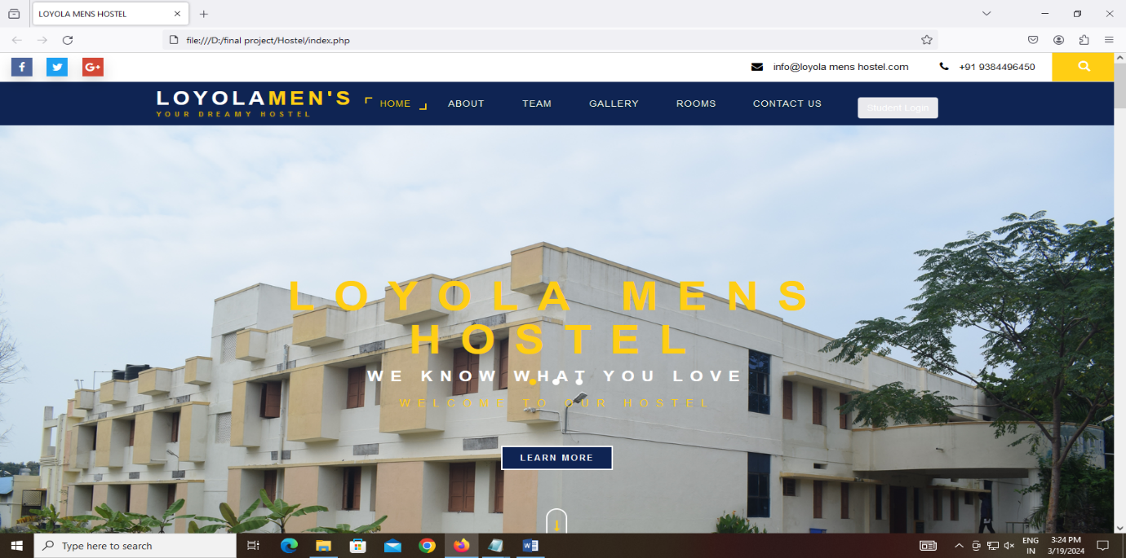
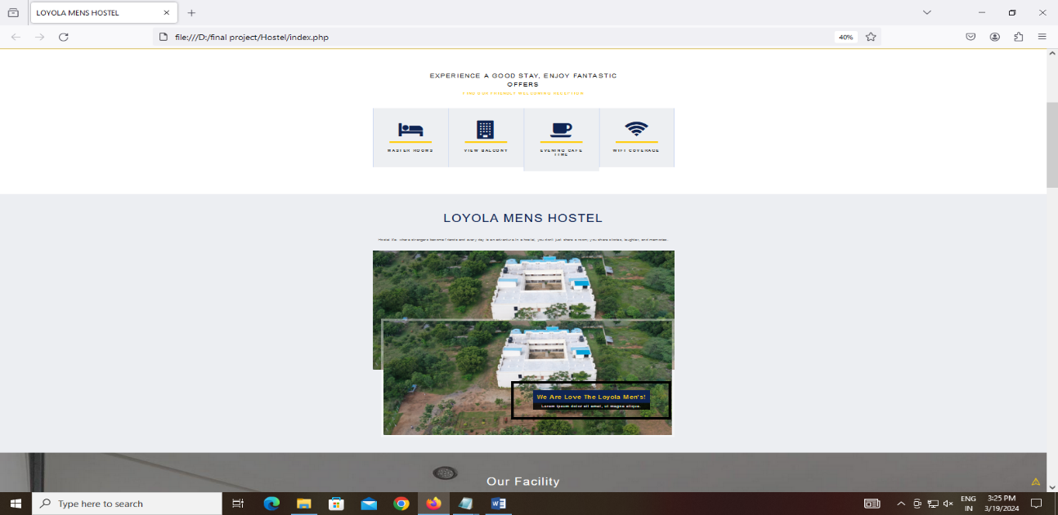

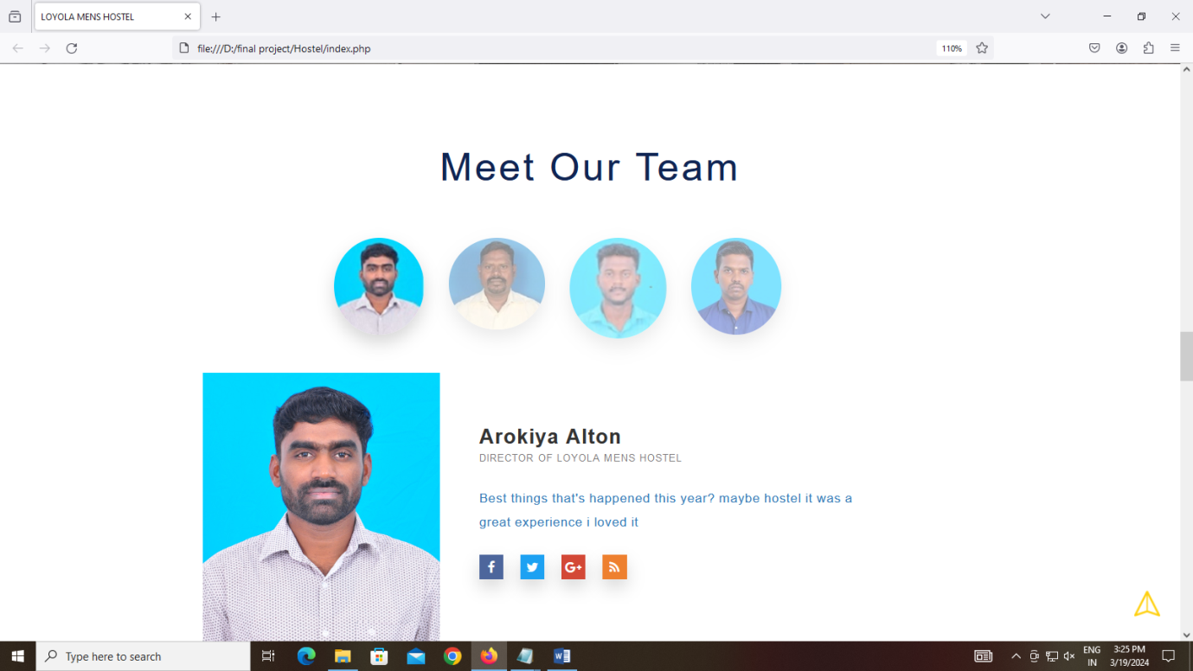

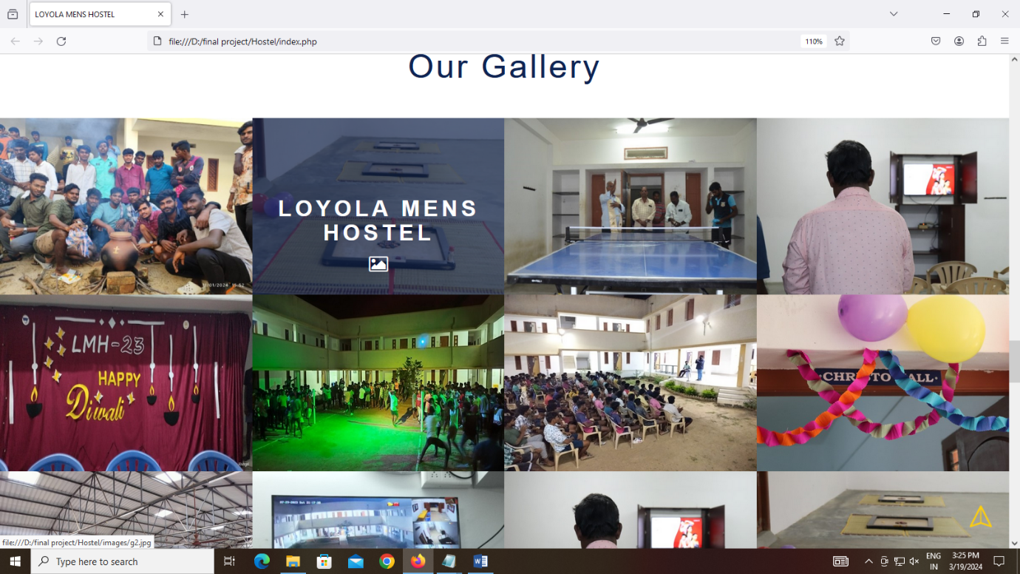

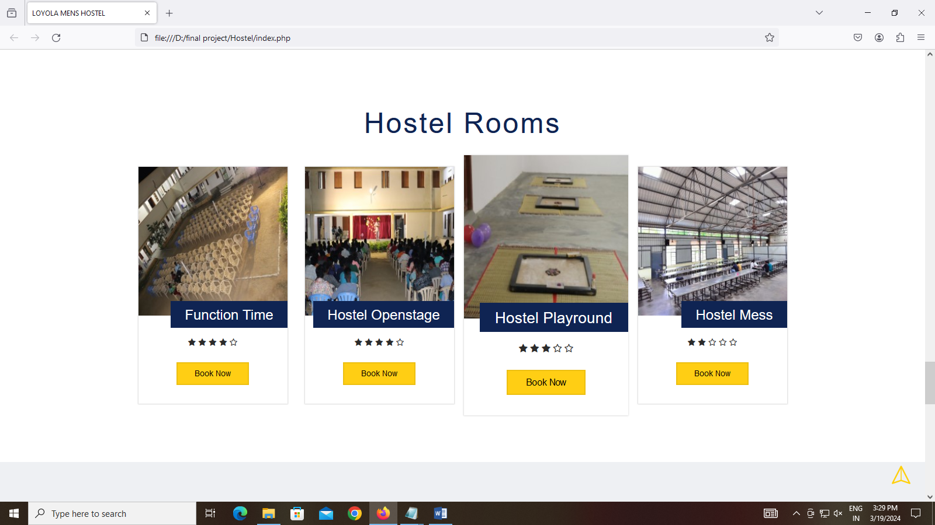

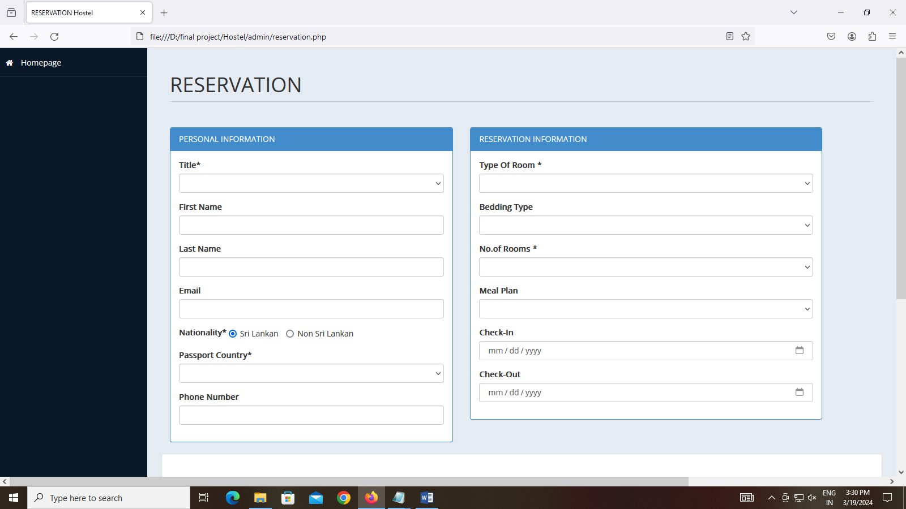

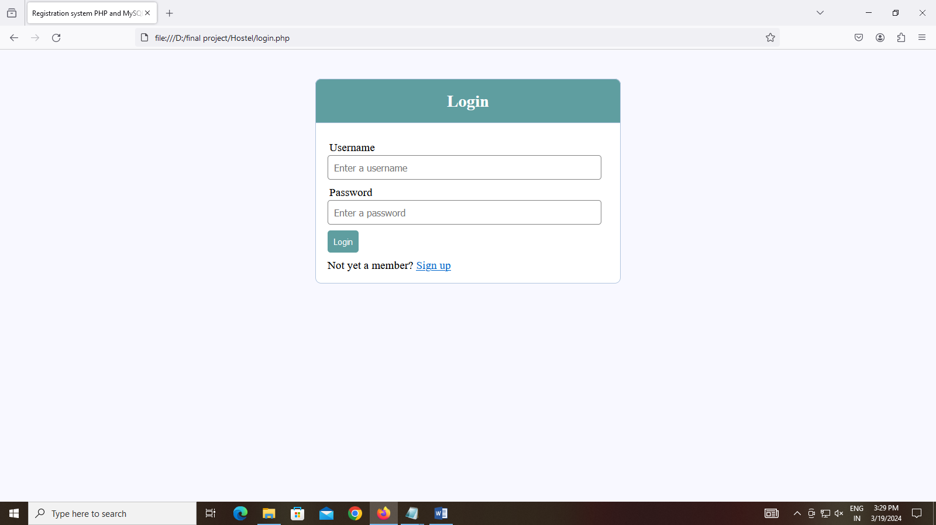

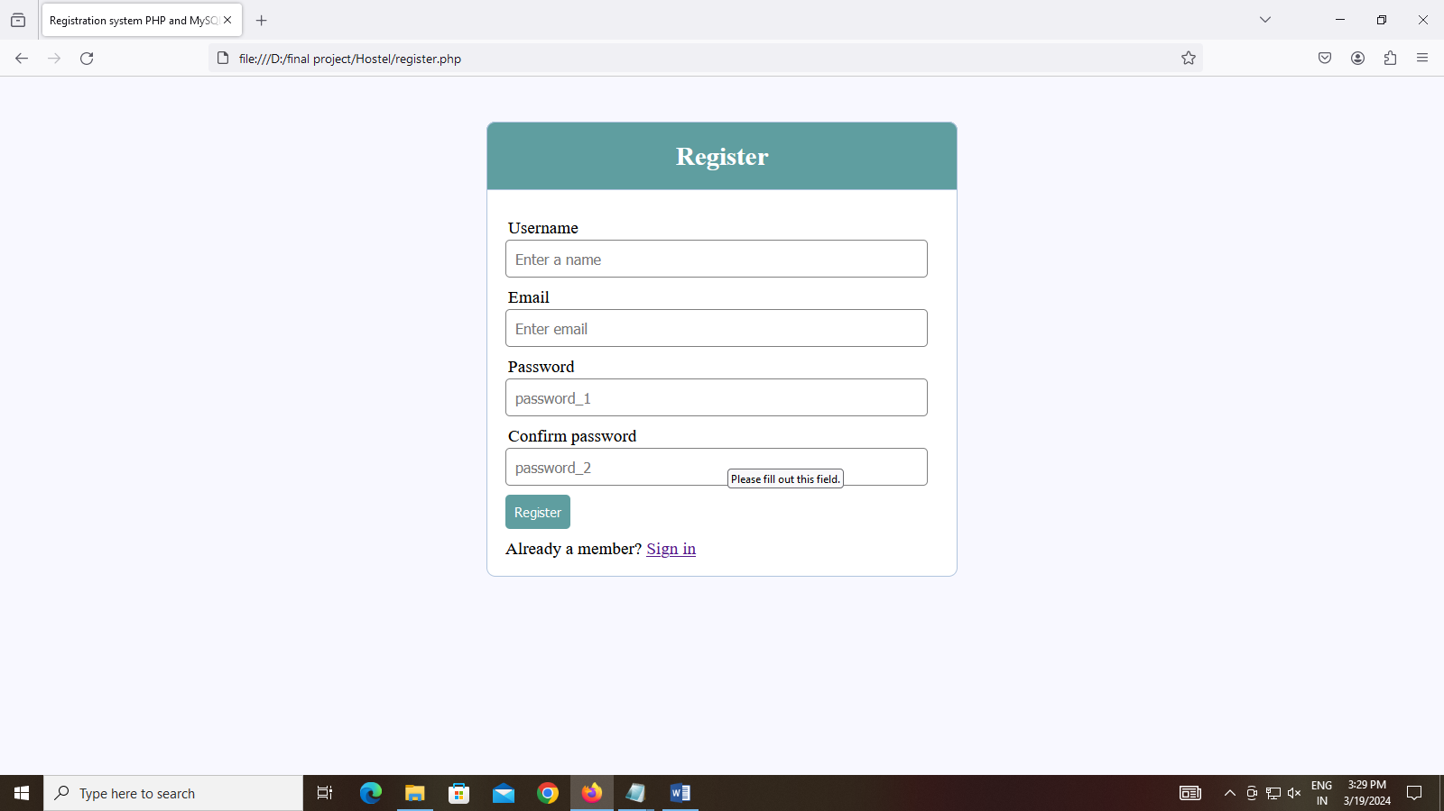
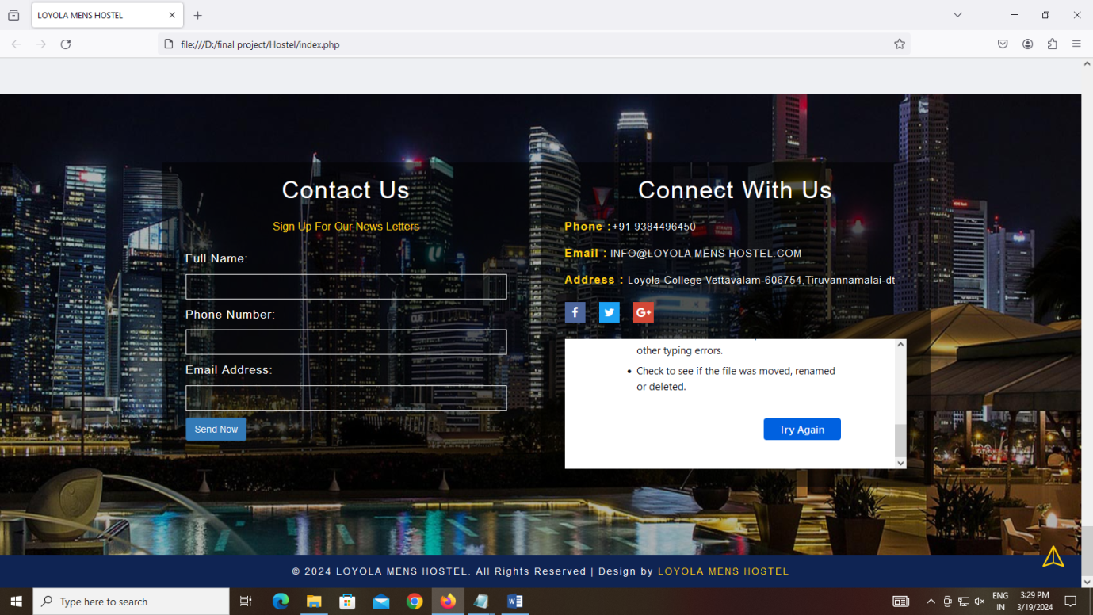

Future Scope

- Artificial Intelligence Integration:
Implement AI-powered chatbots for customer support, handling inquiries, and providing personalized recommendations to guests.Use AI algorithms for predictive analytics to forecast demand, optimize pricing strategies, and improve inventory management.
- Internet of Things (IoT) Integration:
Utilize IoT sensors for real-time monitoring of room occupancy, energy consumption, and environmental conditions (e.g., temperature, humidity) to optimize resource usage and enhance guest comfort.
Implement smart locks and access control systems for secure and convenient room access.
- Blockchain Technology for Security and Transactions:
Utilize blockchain technology to enhance security and transparency in transactions, ensuring data integrity and preventing fraud.
Implement blockchain-based loyalty programs and payment systems for seamless and secure transactions.
- Virtual Reality (VR) and Augmented Reality (AR) Applications:
Develop VR and AR applications for virtual tours of hostel facilities, allowing potential guests to explore rooms and amenities remotely.
Use AR for interactive maps and navigation within the hostel premises, providing guests with directions and information about nearby attractions.
- Enhanced Mobile Experience:
Develop mobile apps with advanced features such as mobile check-in/check-out, digital room keys, and in-app messaging for seamless communication between guests and staff.
Implement mobile payment solutions and digital wallets for convenient and contact less transaction.
- Sustainability Initiatives:
Integrate sustainability features into the hostel management system, such as tracking carbon footprint, implementing energy-saving measures, and promoting eco-friendly practices among guests.
Provide guests with incentives for choosing sustainable options, such as recycling programs or rewards for reducing water and energy consumption.
- Personalization and Customer Experience Enhancement:
Utilize data analytics and machine learning algorithms to personalize guest experiences, offering tailored recommendations, special promotions, and personalized amenities based on guest preferences and past behavior.
Implement guest feedback analysis tools to gather insights and continuously improve service quality and guest satisfaction.

5.5. Conclusion
The hostel website management system stands as a pivotal tool in the hospitality industry, facilitating efficient operations, enhancing guest experiences, and driving business growth. Through a comprehensive array of features and scopes, hostel management systems streamline reservation processes, optimize room allocation, and empower hostel owners and managers with insightful analytics to make data-driven decisions.
As technology continues to advance, the future scope for hostel management systems is ripe with possibilities. Integration of artificial intelligence, IoT, blockchain, and immersive technologies promises to revolutionize guest interactions, sustainability efforts, and operational efficiency. Moreover, a continued focus on personalization, accessibility, and inclusivity ensures that hostel management systems evolve to cater to diverse guest needs and preferences.
In this dynamic landscape, agility and innovation are paramount. Hostel management systems must adapt swiftly to changing market trends and emerging technologies, embracing continuous integration and agile development practices. By doing so, hostel operators can stay ahead of the curve, delivering exceptional experiences that foster guest loyalty and drive sustainable business success.
Ultimately, the hostel website management system is more than just a software platform—it's a catalyst for transformation, empowering hosteliers to create memorable stays for their guests while maximizing operational efficiency and profitability. With the right tools and strategies in place, the future of hostel management is boundless, promising a world of possibilities for hostel owners, managers, and guests alike.

5.5 References

- https://www.youtube.com/@A2DChannel

- https://www.w3schools.com/

- https://www.tutorialspoint.com/index.htm

- https://github.com/

- https://www.geeksforgeeks.org/

- https://www.javatpoint.com/

- https://www.programiz.com/

- https://stackoverflow.com/

